May 2019 - Joint HL7/IEEE WG Montreal, Quebec, Canada
(Draft Meeting Minutes -Pending Review, 10 May 2019)
Revision 1 Friday, May 10, 2019

To help prepare for HL7’s Working Group Meeting, please note the following information:

A copy of the HL7 Working Group On-Site Meeting Schedule can be found here: Onsite Guide. Hard copies will also be available at the registration desk.

You can also find the same information available on our Event Mobile App here: EventMobi App

Meeting Minutes Draft Version 1.0, May 10, 2019
Please NOTE: the following notes are draft and pending members/leadership review and vetting (Draft V1.0, as of Thursday Q3, May 9, 2019)
Please provide IEEE PoCD Chair (John Rhoads) or Secretary (John Garguilo, john.garguilo@nist.gov) any proposed updates/edits/corrections
Apologies in advance for any "fat fingers" or misrepresentations which may be provided in these draft meeting notes.

**Notes not yet complete as of this draft version 1, May 10, 2019 – Pending updates…

IEEE Portion of Meeting (presiding)
IEEE 11073 General Committee Chair: John Rhoads / Ken Fuchs + Malcolm Clarke (via Teleconference)
IEEE 11073 PoCD Chair: John Rhoads
IEEE 11073 PoCD Secretary: John Garguilo

HL7 Portion of Meeting (presiding)
HL7 Healthcare Device Co-Chair: John Rhoads
HL7 Healthcare Device Co-Chair: John Garguilo

Meeting Hotel/Room: Le Centre Sheraton, Montreal, Québec, Canada / Salon Drummond Centre (Level 3, / Niveau)
HL7.org, HL7.me/onsite

Attendance:
Joint IEEE 11073 / HL7 HCD Attendance Site

Notes Key:
Yellow Highlight: Date/Day and Quarter of Meeting)
Red Highlight with box to right: Action Item

Monday, May 6 2019
IEEE Portion of Joint IEEE 11073/HL7 HCD (Day 1)

Q1 Monday May 6, 2019:

Welcome, Introductions, Rules (Officers – Chair John Rhoads)
- IEEE Patent Policy (John Rhoads / John Garguilo)
Review of Previous Meeting Minutes and Action Items (Note: Deferred/moved to Q3)
- AAMI (Beth Pumo)
- Cybersecurity (John Rhoads)
- Unique Device Identification (UDI) (Rhoads)
- IEEE 11073 Status Review (IEEE-SA Tom Thompson, Jodi Haasz)
- Center for Medical Interoperability (CMI) (Paul Schluter)

Q2 Monday May 6, 2019:
- PHD Updates (PHD/PCHAlliance/Continua) (Malcolm Clarke / IEEE Staff -Thompson, Haasz)
- Status Review of 11073-20601, 11073-4xx Series
- Status of PHD (from IEEE Ballot System)

Q3 Monday May 6 2019:

- 10101R Terminology - comments and discussion (Malcolm Clarke / Paul Schluter)
- IEEE Review of Previous Meeting Minutes and Action Items (Rhoads/Garguilo)
- Updates on related SDO work (Thompson, Haasz, Rhoads, Clarke)

Q4 Monday May 6 2019:

- Naming Recommendations (new) for IEEE 11073 family of Stds (Ken Fuchs / Jodi Haasz)
See HCD Documents Site: http://www.hl7.org/Special/committees/healthcaredevices/docs.cfm
- Form a liaison with IEC 80001-5-1 (formal?) (Schlichting, Kasparick / FDA- Kosta)
- x73 standards in governmental listings (Paul Schluter)
- Dialysis Project Update (Schluter)
- LOINC Mapping Status (Swapna Abhyanker)

Tuesday, May 7 2019
Q1 Tuesday May 7 2019:

Q1: HCD Joint w/ O&O
Joint w/ @Orders and Observation WG
(Meeting Room: Salon Kafka-Lamartine)
Device Maturity Level (Maturity Level 2?)
Parts Device of Normative/Informative

https://confluence.hl7.org/display/OO/Healthcare+Product

Discussion w O&O on FHIR Device Resource (Brian Reinhold + others)
See O&O meeting minutes

IEEE Portion of Joint IEEE 11073/HL7 HCD (Day 2)

Q2/Q3 Tuesday May 7, 2019:
Co-Chair report out from DESD & HL7 Co-Chairs meetings (Rhoads / Garguilo)

SDC Update new work / OR.NET (S. Schlichting, Martin Kasparick, and Anton Keller)
See Slide sets: http://www.hl7.org/Special/committees/healthcaredevices/docs.cfm

Note: On-line participants:
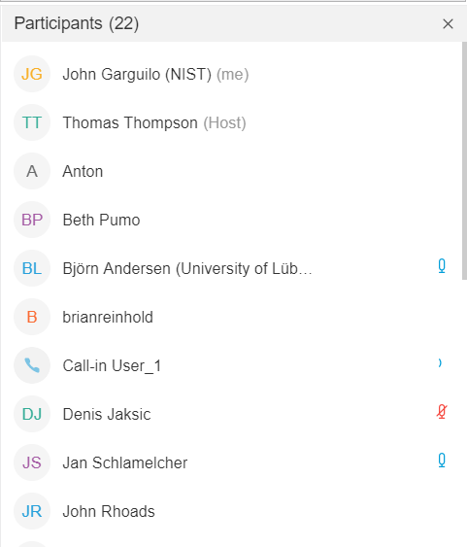

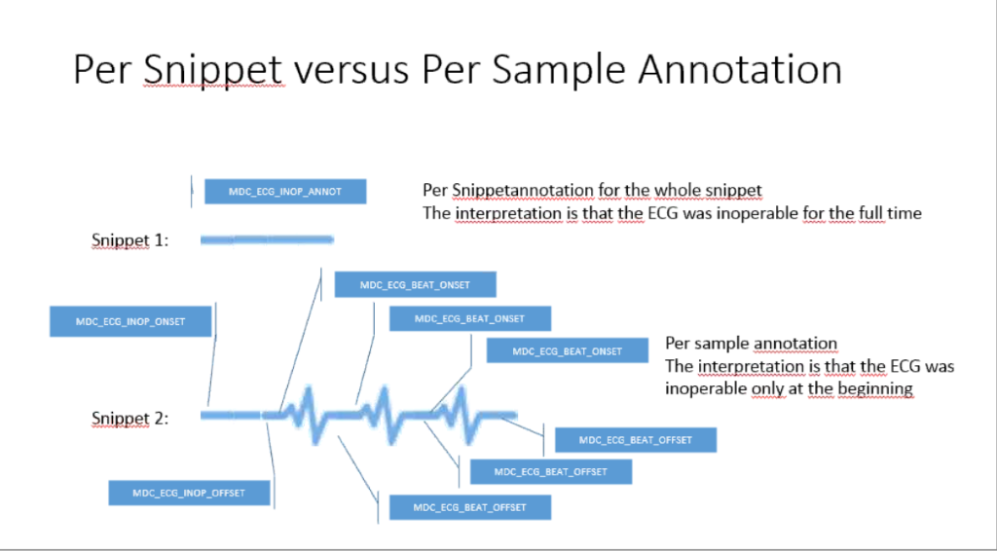
Q3

Conformance Principles

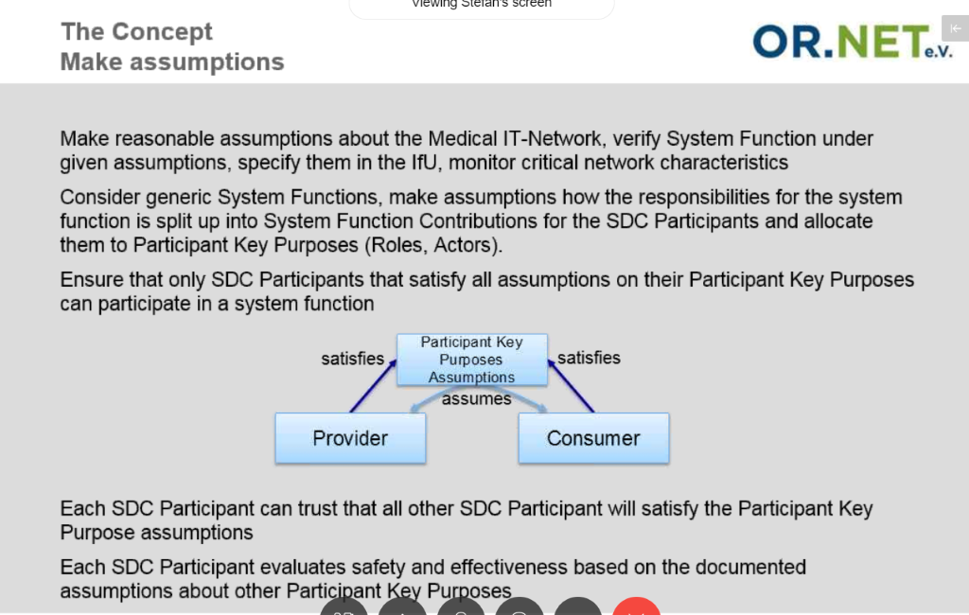

Noted by IEEE-SA staff: IEEE rules state no pictures may be taken during a working group meeting. (Pictures can be taken during "breaks").

Q4 Tuesday May 7, 2019:
Agenda Update & review
- Discussed and agreed on Wednesday & Thursday Items

FDA Discussion / Brainstorm (Kosta)
- Kosta presented an initial slide set for discussion and brainstorming...
- Slide set will be shared with understanding these are an initial set and just to start the discussion
- Kosta hopes this will start additional brainstorming
- Noted a Listening session @ FDA on July 18th, 2019

IEEE Pending Deadlines discussion (Tom Thompson)
- Tom mentioned we need to consider the following to know how we move forward, if the pending is to be worked on, or take an alternative route...
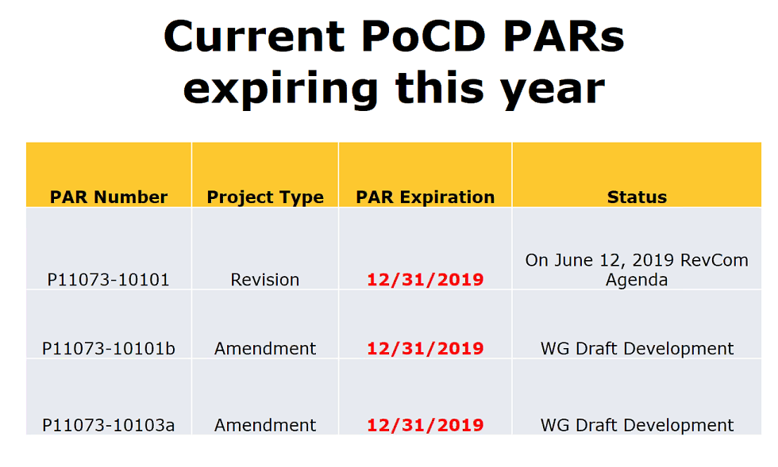
Five or more years out:
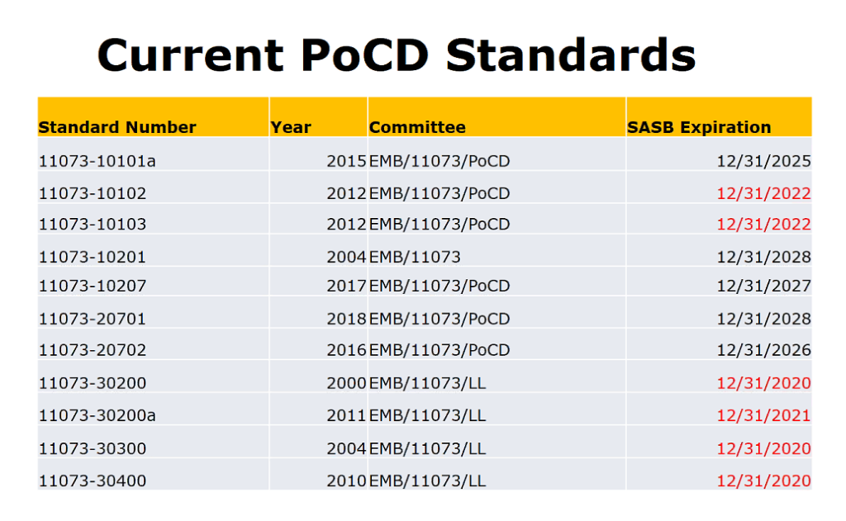
Close IEEE Portion of meeting:
Motion to Adjourn: Paul Schluter, Second Stefan Schlichting
Motion Approved: 14-0-0

Q5 Tuesday May 16, 2019:
Birds of a Feathers session on "Research Standards for All of Us" (5:15 PM Salon 7)

Wednesday May 8, 2019
Start of HL7 Healthcare Device Portion of Joint WG meetings

Teleconference service:
https://www.freeconferencecall.com/wall/healthcaredevices
- Access Code: 609410

Q1 Wednesday, May 8, 2019

HL7 HCD Portion of Meetings
Welcome and Introductions (Garguilo and Rhoads)
- See Attendance: https://confluence.hl7.org/pages/viewpage.action?pageId=51219489
Intellectual Property Policy Reviewed (Rhoads
DEV WG Agenda Review (Garguilo)
NIST RTMMS II Planning (Michael Faughn and John Garguilo)
NIST Tooling
--IHE Profile Tool
--Dim Profile Tool
See slide set provided by Michael Faughn
- Discussion provided about moving to a RTMMS II (a new version to accommodate new and improved interfaces and functionality)
- Discussion given by Michael Faughn regarding a profile builder that would essentially provide a way to develop profiles that (through a "shim") could be integrated in with both the 11073 Nomenclature and Domain Information Model. It turns out that such a tool would be helpful and promote usage and more comprehensive profile (tied to standards)

Q2 Wednesday, May 8, 2019

FHIR Ballot Resolution (Martin Rosner + Brian Reinhold)
Comments from Clem McDonald (NLM) {GForge};
- Profile Overview Section
  - Discussion on the level of detail in the Overviews (e.g., "Profile Overview")
    - Suggestion to step back and look at overall structure of document, perhaps taking details out of overview and reference the detailed sections...
  - Brian mentioned he worked with Anna to come up with text
  - Part of the issue – FHIR framework tool (which is still advancing) dictates the structure
- Resolution: Clem, Martin Rosner and others help review and take a fresh look at descriptive text
  - Perhaps share in a MS Word file and then figure out where in the FHIR system text would go
- Add a top page to provide user a clue of the "small" (PHD) and "large" (PoCD) devices – to let user know right up front where and what they are about to dive into...
- Clarify text...

Note: See GForge site for Martin Rosner's updated comments...
Clem had the only negative votes – nearly all comments reviewed; will be continued after WG meeting.

Recommendation on a few books (suggested by participants regarding how to present content):
"Readers over your shoulders" by Robert Graves
"Revising Prose" by Richard Lanham

Q3 Wednesday, May 8, 2019

Terminology (Paul Schluter)
- See Slide set from Paul – some highlights provided below…
- http://www.hl7.org/Special/committees/healthcaredevices/docs.cfm

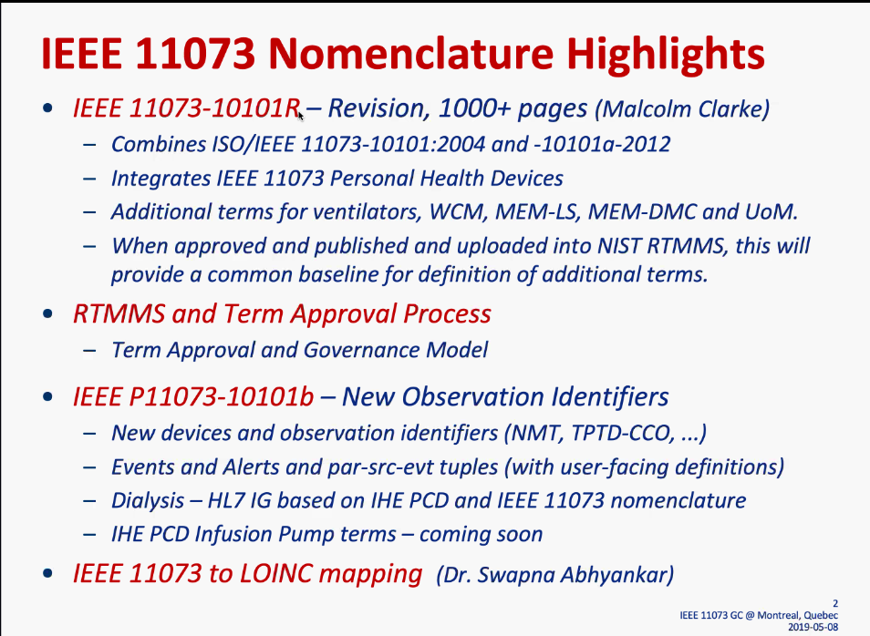

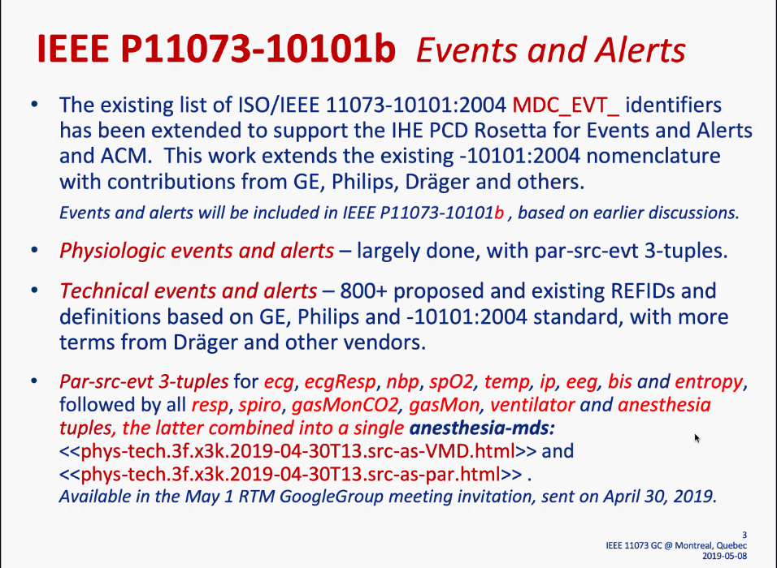

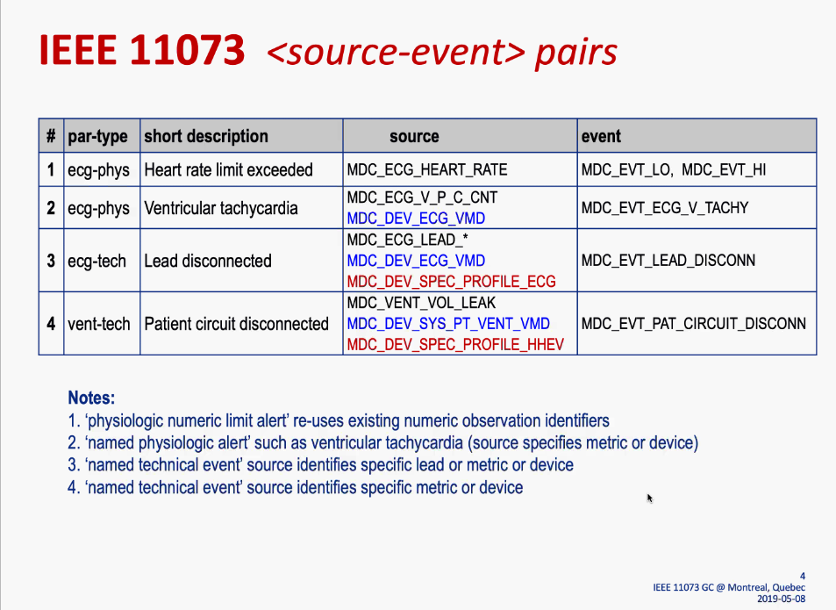

New Devices: Hoping for September 2019 time frame (perhaps after Joint HL7/IEEE WG meetings in Atlanta)

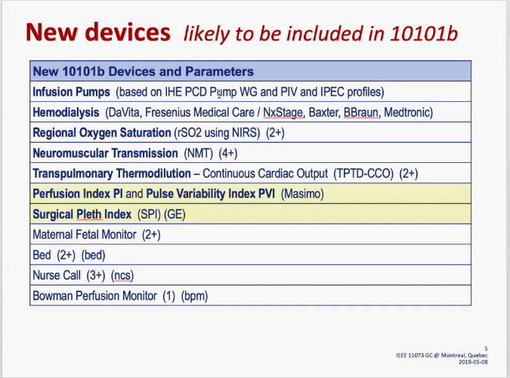
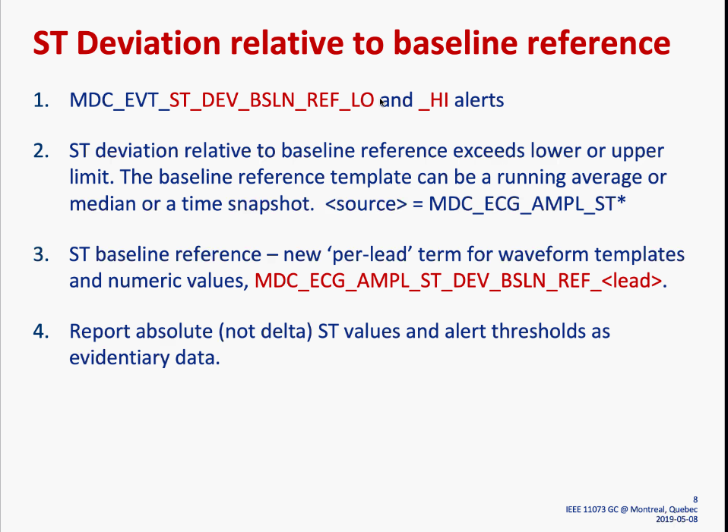

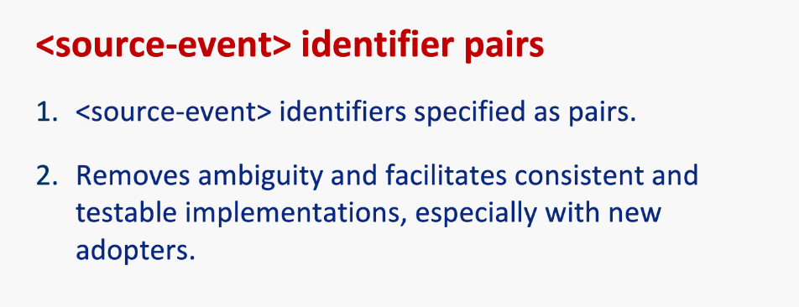

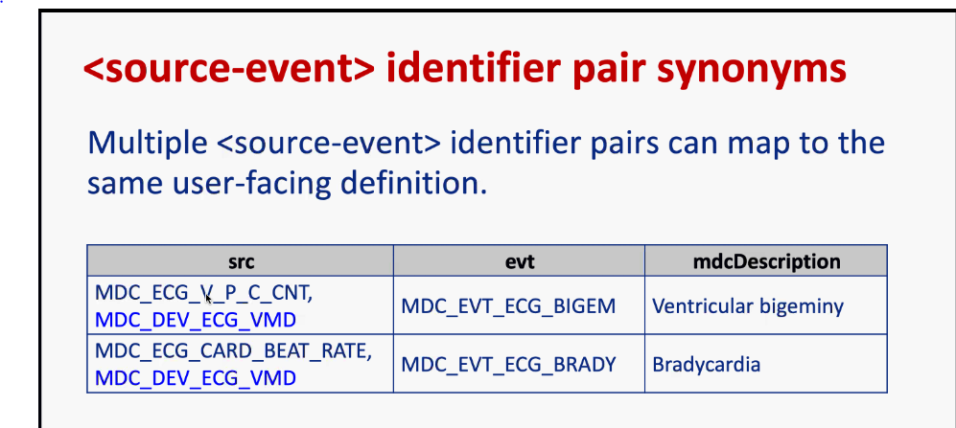
--Note will adopt concept of "preferred" Term of synonyms – shown here by how ordered (first – most preferred)

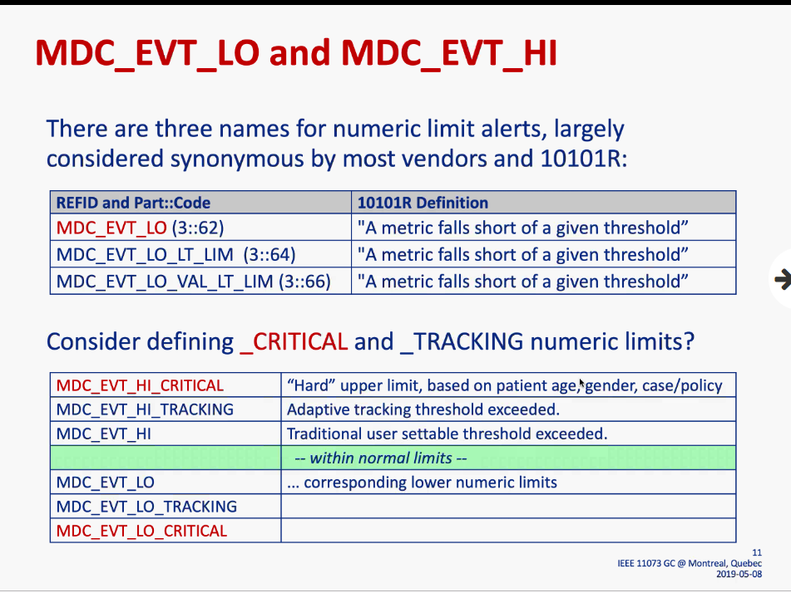
Paul recommends adding a "Critical" which could be a different numeric threshold (perhaps that couldn't be adjusted – say by the nurse/programmer)

Swapna Abyankar (Regenstief):
Question on working FHIR mapping concepts...
**John Rhoads is working on this effort – Swapna and John will contact each other to move the effort forward.

Q4 Wednesday, May 8, 2019

Joint with Mobile (Matt Graham)
See Slide set
http://www.hl7.org/Special/committees/healthcaredevices/docs.cfm
Two Projects:
- CMHAFF - Consumer Mobile Healthcare Application Functional Framework (cMHAFF) -mLabel – Consumer Labeling for Mobile Health Applications
- SHIFT - School Healthcare Information Framework utilizing Technology (SHIFT)

Terminology Management Discussion (Malcolm Clarke and Michael Faughn)

Discussion on process to advance terminology (and proposed to be included in the future RTMMS II NIST site, presently rtmms.nist.gov…
Michael Faughn will put something together to reflect conversation and path forward

Q1 Thursday, May 9, 2019

Note: NO FHIR Representative(s) attended HCD Q1 – the designated joint meeting - so other agenda items were discussed (which were originally scheduled for Q2)

IHE- PCD Updates:

Discussion on ACM (Alerts):
Kosta asked a few questions regarding meetings and work being held in IHE ACM WG.

Martin Kasparick mentioned there are indeed 5 most important alerts and management – but there is yet another level of risk management in which 100s of important alerts...

Discussion on display (Paul Schluter) about displaying and validating to get rich data for a variety of devices and address things link "false positives", if an acknowledgement is addressed, etc. (aka "round trip loop").
Paul mentioned another exciting area which could potentially handle, via AI, where a system handles short term silencing to handle false positives and revert back to alarming and alerting...

Point-of-Care Identity Management (another area being worked on in IHE-PCD)

PCD continues to help with testing at Pre-/Connectathon...
Ongoing refinement of profiles...

HL7 DEV General Roadmap and Planning Topic (John Rhoads)
- Tendency has been the V2 work has been done within IHE (PCD) and it also involves the testing.
  - There have been some examples in the past (Hearing and Birthing Profiles) were developed in IHE but the founders of that work

(John Rhoads)
Sentiment expressed that within HCD and related work, is that FHIR will not replace V2 work, but certainly has a role moving forward and looks to be getting better and better. Noted to contribute to FHIR efforts to ensure getting device related descriptions correct.
However, device data doesn't "die" when it gets to EMR – there's a need to put these in a repository, used for clinical research (big data analytical) - FHIR will likely play a key role in this part of the story. Thus, there is a key need to continue looking at Device-to-device level, at the point-of-care, at SDC and throughout the ecosystem.

There are currently a couple of projects within FHIR

(Beth Pumo) From a regulatory perspective there is more 'pressure' to have FHIR resources – however most are sitting on V2 Interfaces that are "not broken". Beth mentioned that FHIR will be mandated. Likely a 5-10 horizon – starting with HER systems – do NOT want healthcare devices to have a delay. Are seeing more from ONC and CMS to ultimately become a reality.

(Paul Schluter) A realistic view, is that FHIR is not ready for prime time. 5-10 year horizon is fine, but vast majority of EHR will continue (and Paul has gotten push back regarding FHIR). FHIR just has not gotten the testing so the horizon is a bit far off...
Beth noted that Providers will have to look at suppliers/vendors at some point, and if not considering FHIR will be potentially
Paul mentioned the need for translator ("flux capacitor" model). Thus, a clear road map is important of how we get to FHIR, but there will always be vendor specific solutions (as things work now and work really well now...). Paul in not sure FHIR is not geared up to do the transfer and at rates needed. Also, certainly an economic issue as well...
Beth noted this sentiment is from the Vendor/Manufacturer, not Provider who will be required
Kosta noted when involved w/ FHIR is a longer-term goal, and there must be a clear roadmap. And also, some clear evidence that V2 does not have errors.

Beth suggested that FDA be in touch w/ ONC and CMS. Kosta mentioned the key is how we address and achieve interoperability issue...

Q2 Thursday, May 9, 2019

NIST Tool and Test Infrasturcture Update: (Garguilo)
- John Garguilo provided an overview of test activities, tools, and plans.
- John described the NIST V2 Test Framework including IGAMT and TCAMT Tools.
- Please refer to Slide Set provided.
  - http://www.hl7.org/Special/committees/healthcaredevices/docs.cfm

Carry Over Topics
- None
Motion to Adjourn HL7 HCD WG meeting:
Motion made by Beth Pumo, second by Paul Schluter
Motion accepted 11-0-0 (includes call in attendees)
**Note to Co-chairs: Register for room reservations with HL7 for September/Atlanta

