  - C-CDA Value Set Maintenance Process
July 2017
Prepared for Health Level Seven (HL7) International
Lantana Consulting Group
PO Box 177
East Thetford, VT 05043
www.lantanagroup.com
Liora Alschuler
Chief Executive Officer
liora.alschuler@lantanagroup.com
Rick Geimer
Chief Technology Officer
rick.geimer@lantanagroup.co
Linda Hyde
Terminologist
linda.hyde@lantanagroup.com
Don Lloyd
Project Manager
don.lloyd@lantanagroup.com

Acknowledgments
This material contains content from SNOMED CT® (http://www.snomed.org/snomed-ct/). SNOMED CT is a registered trademark SNOMED International.
This material contains content from LOINC® (http://loinc.org). The LOINC table, LOINC codes, and LOINC panels and forms file are copyright © 1995-2014, Regenstrief Institute, Inc. and the Logical Observation Identifiers Names and Codes (LOINC) Committee and available at no cost under the license at http://loinc.org/terms-of-use.
Contents
Introduction 1
Audience 1
Scope 1
Process Details 2
Step 1. Invoke the Value Set Maintenance Process 2
Step 2. Identify the Update Team 3
Step 3. Identify Impacted Value Sets and Recommended Changes 3
Step 4. Involve Value Set Stakeholders 3
Step 5. Review/Approve Proposed Changes 4
Step 6. Implement Changes in VSAC 4
Step 7. Review/Publish Changes in VSAC 4
Step 8. Implementer Outreach (changes available, go to VSAC for updates) 4
Step 9. Update Cycle Close and Debrief 5
Step 10. Update/Refine Value Set Maintenance Process 5
Acronyms and Abbreviations 6
Appendix A - Value Set Errata on the HL7 STU Comments Page 7
Create a New Comment 7
Reviewing Comment Details, Changing Status and Disposition, or Editing Version Implemented 9
Appendix B - Working in VSAC 12
Creating New Value Sets in VSAC 12
VSAC Access 12
Creating a New Value Set 12
Updating an Existing Value Set in VSAC 13
Appendix C - Reviewing Draft Value Sets in the VSAC Collaboration Tool 17
Collaboration Site Creation 17
Collaboration Site Distribution and Stakeholder Notification 17
Draft Value Set Review 17

Figures
No table of figures entries found.
Tables
No table of figures entries found.

Introduction
This document details the maintenance process for the creation of, corrections to, and ongoing maintenance of Consolidated CDA (C-CDA) value sets in Value Set Authority Center (VSAC).

Audience
This document is prepared for the HL7 Structured Documents Work Group (SDWG), other HL7 workgroups such as Vocab, VSAC representatives, and other stakeholder groups.
This document assumes that persons implementing this process are either terminologists or have a substantial background in clinical terminologies.

Scope
The scope of this document is limited to updates to C-CDA R1.1 and R2.1 value sets, particularly those that occur due to errata or due to changes in the underlying code systems (SNOMED, LOINC, etc.).
Feature request and additions for future releases of C-CDA, while not technically in scope, could also be handled with minor changes to this process.

Process Details
The value set maintenance process uses ten steps, listed here and detailed in subsequent sections.
- Invoke the value set maintenance process
- Identify the update team
- Identify affected value sets and recommend changes
- Involve value set stakeholders
- Review/approve proposed changes
- Implement changes in VSAC
- Review/publish changes in VSAC
- Implementer outreach (changes available, go to VSAC for updates)
- Update cycle close and debrief
- Update/refine value set maintenance process

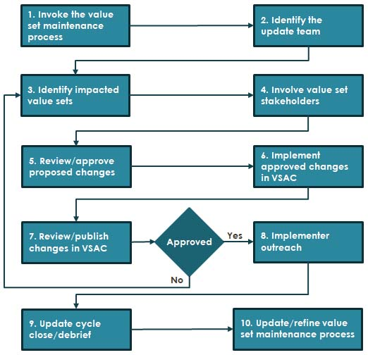
Figure 1: Value Set Maintenance Process

Step 1. Invoke the Value Set Maintenance Process
This document identifies two situations where the value set maintenance process should be invoked.
- Regularly scheduled updates: Regularly scheduled updates occur 3 times per year, coinciding with HL7 working group meetings (WGMs). The process should be invoked no less than 2 weeks in advance of the working group meeting,
- Ad hoc updates: Ad hoc updates occur when there is a pressing need to update value sets outside of the regular schedule, for example, a patient safety issue requires immediate action.
Once the process has been invoked, SDWG holds a kickoff meeting to discuss value set updates. The kickoff may be held on a regular weekly SDWG call or on a special call, at the discretion of the SDWG co-chairs. During the kickoff, SDWG provides an overview of this process (either by reviewing this document or preparing a presentation summarizing the process) and discusses composition of the update team. The update team will take responsibility for the process, involving SDWG and other stakeholders as noted in the following steps.

Step 2. Identify the Update Team
The update team has primary responsibility for leading all the steps that follow.
SDWG issues a request for volunteers during the kickoff meeting. Any volunteer may join, but the team is not considered complete until it contains at least one SDWG co-chair and one terminologist that is familiar with VSAC.

Step 3. Identify Impacted Value Sets and Recommended Changes
This document recognizes two situations that may require value set updates:
- Approved errata
- Changes to underlying code systems
The update team reviews two information sources for affected value sets and changes needed:
- SDWG’s current list of unimplemented approved errata (currently stored in the C-CDA DSTU Comments Page, see Appendix A for details)—The update team compiles a list of value sets impacted by errata. The disposition listed in the errata is the recommended change for the value set.
- The list of code systems used in C-CDA (SNOMED, LOINC, etc.) at the time of a new releases of the code systems (an underlying code system change). For these changes to the underlying code systems, the update team will do the following:
  - For dynamic value sets, determine if the code system update results in an expansion different from that currently stored in VSAC. If so, the value set goes on the impacted value set list, and the new expansion is listed as the recommended change.
  - For static value sets, determine if any of the codes in the value set have been deprecated or if new codes meeting the value set definition have been added to the underlying code system(s). If so, log a potential erratum for the value set. The errata must be discussed using the errata process, and if approved, the value set goes on the impacted value set list and the recommended change is to remove any deprecated codes, add new codes, or add any suggested replacement codes.

Step 4. Involve Value Set Stakeholders
Each time the value set maintenance process is invoked, the update team reviews the list of impacted value sets against the value set stakeholder list. During this review, the update team may add or remove stakeholders from the list if deemed necessary and appropriate.
The update team alerts stakeholders that a change has been proposed for value sets of interest to them. The update team solicits feedback from stakeholders, posting a listing of the affected value sets and the proposed changes. Stakeholder feedback may be delivered on a call or may be sent via email. Stakeholders are invited to any calls where updates to value sets of interest to them are discussed, and they are invited to review/approve changes to value sets per the steps listed below.
At ad hoc meetings, attendance will be taken establish stakeholder participation. If a stakeholder group is not represented, an email notification will go out to that group notifying them that their value sets were discussed.

Step 5. Review/Approve Proposed Changes
The update team schedules a meeting to review and approve proposed changes. This meeting may occur on an existing SDWG call, during a live WGM session, or on a separate call, provided that SDWG’s rules for quorum are met. All identified stakeholders are invited to either attend the call or send written recommendations to the update team via email in advance of the meeting. Stakeholders will be given at least 1-week notice so they may either attend the meeting or provide written feedback.
During the meeting, feedback from any ad hoc reviews will be presented along with a tally of stakeholder attendees, and the recommended changes and rational for value set changes will be reviewed and discussed. During discussion, recommended changes may be modified with the assent of attendees. SDWG must vote to approve recommended changes. If approved, each recommended change goes on the list of changes to implement in VSAC. Any proposed changes not approved may either be tabled for future discussion, directed to stakeholder groups for additional input, or added to future errata lists.

Step 6. Implement Changes in VSAC
The update team implements approved changes in VSAC, leaving the updated value sets in draft status, and potentially flagging groups of value sets with key works to group them for review. This process recognizes that VSAC is undergoing substantial change and the actual process for implementing updates will change over time. The VSAC update process, as of July 2017, is detailed in Appendix B.

Step 7. Review/Publish Changes in VSAC
After the value set changes are implemented in VSAC, the update team schedule time on an SDWG meeting for review. This meeting may occur on a regularly scheduled SDWG call, during a WGM session, or on a separately scheduled call provided that SDWG’s rules for quorum are met. Value set stakeholders are given at least a 1-week notice so they may either attend the call or provide feedback in writing via email, and that notice must include a reference (i.e., link) to the updated content in VSAC. Attendees may also review draft value sets offline using the VSAC Collaboration Tool and basic directions on accessing and using the tool will be included in the email notification. (See Appendix C for the process, as of September 2017.)
During the review of draft VSAC changes meeting, if attendees agree that the value set changes have been implemented correctly, they will vote to publish the changes.
If the attendees decided that the proposed changes have not been implemented correctly, those value sets will return to Step 3 and this process will repeat from there.
Once value set changes in VSAC are approved, the update team uses the VSAC tools to publish the value sets. (See Appendix B for the process, as of July 2017).

Step 8. Implementer Outreach (changes available, go to VSAC for updates)
After value set changes are published, the update team works with SDWG and HL7 to alert implementers to the relevant changes. At a minimum, this step requires emails to the SDWG listserv, but may also include posting a C-CDA errata package to the HL7 website.

Step 9. Update Cycle Close and Debrief
Following the publishing of value sets in VSAC, the update team schedules a meeting to discuss the process itself, identify pain points, lessons learned, etc., and compiles a list of recommended changes to the process itself in the form of a debrief report.
The debrief report will also summarize completed work and any remaining work not completed. In instances where issues remain with value sets, the update team will also deliver to SDWG a listing of those value sets summarizing outstanding issues.
The goal of this step is to ensure that the value set maintenance process is self-correcting and responsive to changes in technology, terminology, best practice, and standards development in general.

Step 10. Update/Refine Value Set Maintenance Process
The update team revises this document based on the list of recommended changes to the process from the previous step. These changes are posted as a draft to the SDWG documents page (http://www.hl7.org/Special/committees/structure/docs.cfm?) at least 1 week in advance of a regularly scheduled SDWG call. During that next SDWG call, the changes are reviewed, discussed, and either approved by vote or adjusted, triggering a repeat of step 9 and 10.

Acronyms and Abbreviations
C-CCA Consolidated CDA
CDA Clinical Document Architecture

HL7 Health Level Seven

IT information technology
LOINC Logical Observation Identifiers Names and Codes
NIST National Institute of Standards and Technology

SDWG Structured Documents Working Group
SNOMED CT Systematized Nomenclature of Medicine, Clinical Terms
VSAC Value Set Authority Center
WGM working group meeting

- Value Set Errata on the HL7 STU Comments Page

Create a New Comment
Errata C-CDA value sets are currently added and tracked using the HL7 DSTU Comments page (http://www.hl7.org/dstucomments). The current steps are as follows:
- The commenter who has identified potential errata (either a change to an existing value set or the need for a new value set) signs in to the HL7 web site. This is necessary because the ‘Create a New Comment’ page captures user information from the user logon id.
- The commenter navigates to the HL7 STU Comments site (http://www.hl7.org/dstucomments/index.cfm) and selects the appropriate C-CDA STU Comments page (see Figure 1). There are separate pages for the currently available versions of C-CDA (note C-CDA 2.0 is not listed since it has expired):
  - C-CDA 1.1: http://www.hl7.org/dstucomments/showdetail.cfm?dstuid=82
  - C-CDA 2.1: http://www.hl7.org/dstucomments/showdetail.cfm?dstuid=168
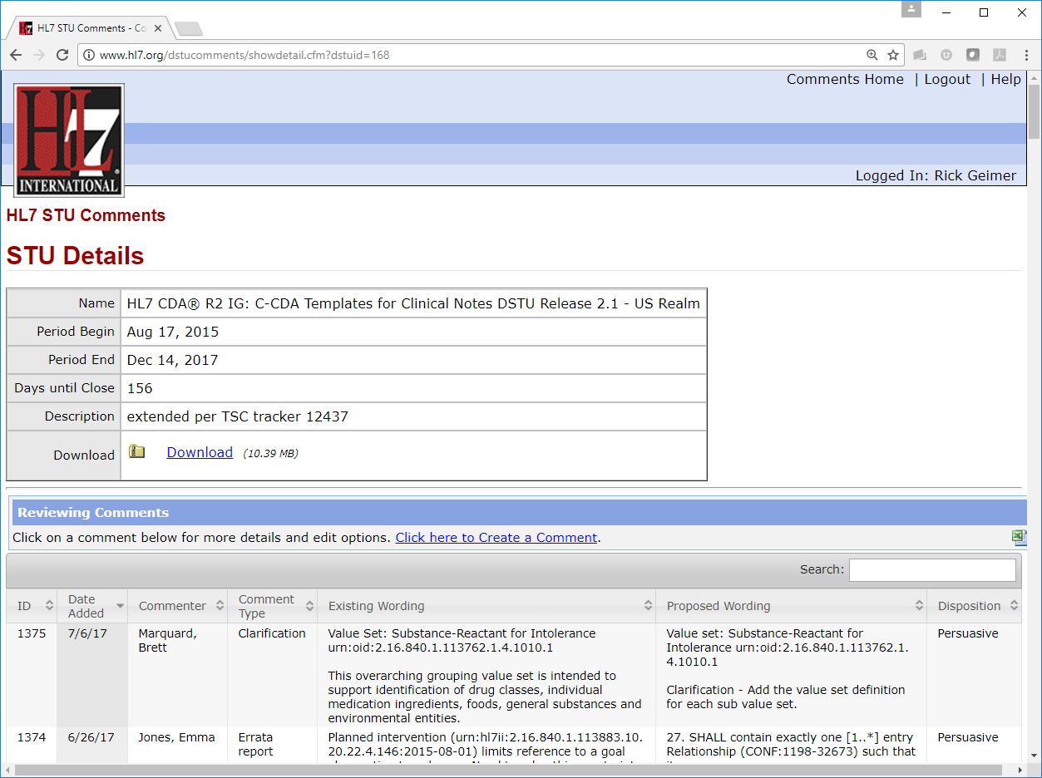
Figure 1 – DSTU Comments page for C-CDA R2.1

- The commenter clicks the link to create a comment, opening the enters the following information into the form (see Figure 2):
  - Existing wording or value set information from the existing standard (optional)
  - Proposed wording or value set information (required)

Figure 2 – Create a New Comment page

Clicking ‘Save your Comment’ will save the form data. The form will capture the necessary user information from the logged user session.
The new comment will now be available for review by the Structured Documents WG.

Reviewing Comment Details, Changing Status and Disposition, or Editing Version Implemented
Note that WG Co-chair permissions are required to change comment status or disposition or to edit version implemented information.
- The comment reviewer or WG co-chair (referred to hereafter as reviewer) signs in to the HL7 web site ().
- The reviewer navigates to the HL7 STU Comments site (http://www.hl7.org/dstucomments/index.cfm) and selects the appropriate C-CDA STU Comments listing (see Figure 3). There are separate pages for the currently available versions of C-CDA (note C-CDA 2.0 is not listed since it has expired).
The STU Details page for the selected C-CDA standard will list summary information for the displayed comments. Note that a spreadsheet of all comments can be download by clicking the Excel spreadsheet download button () display at the far right of the Create a Comment link below the Reviewing Comments header.
- The comment selects the appropriate link from the listed comments to be taken to that Comment Details page (see Figure 3).
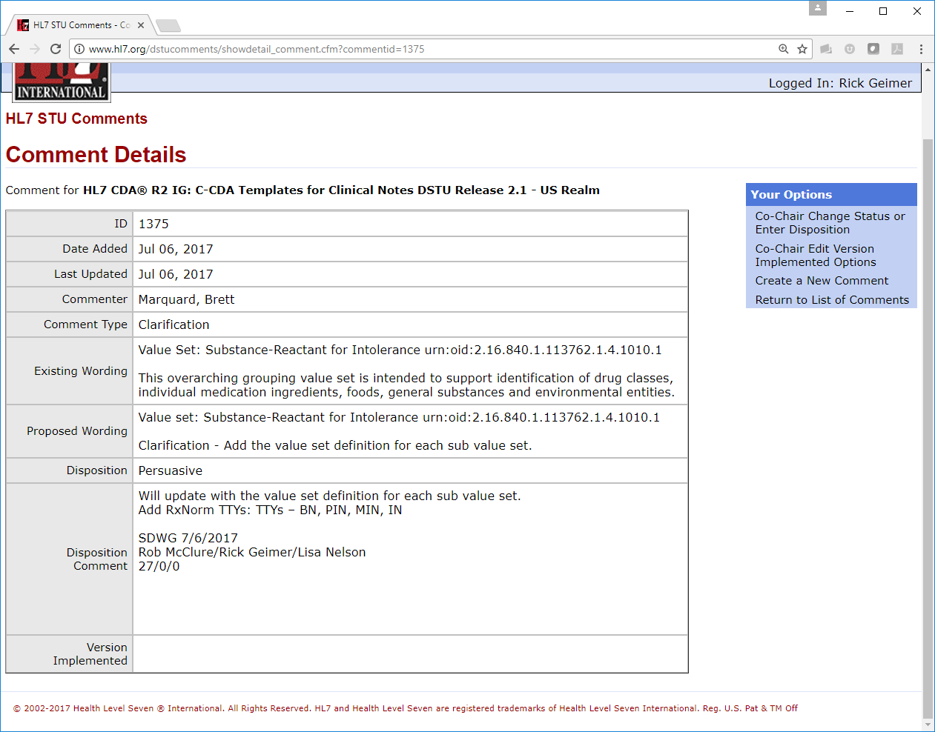
Figure 3 – DSTU Comment Details page

- If the reviewer has the appropriate permission (i.e., WG co-chair), he or she can perform additional actions on this page:
  - Change comment status or enter disposition
  - Edit version implemented options
- If updating a value set comment status or disposition, the SDWG will co-chair will select the Co-Chair Change Status or Disposition button on the Comment Details page.
- The Change Comment Status/Disposition page (see Figure 4) is used to update comment status and disposition information.
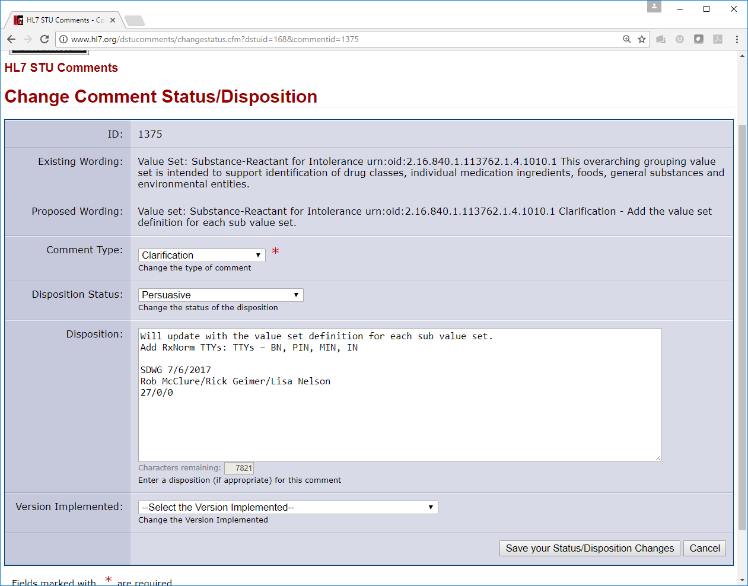
Figure 4 – DSTU Status/Disposition Changes page
The disposition status will be updated to the appropriate value using the Disposition Status dropdown.
The disposition will be entered into the Disposition text box (note the 8,000-character limit).
Clicking the Save your Status/Disposition Changes button will save the changes.
- If updating the version implemented information for a specific comment, the SDWG co-chair will select the Co-Chair Edit Versions Implemented Options button on the Comment Details page.
The correct version can be selected from the Version Implemented dropdown.
Clicking the Save your Status/Disposition Changes button will save the changes.

- Working in VSAC

Creating New Value Sets in VSAC
When necessary, new Value Sets will be created and added to VSAC.
    - VSAC Access
- All individuals must have a current UMLS License to access VSAC.
- Individuals who are creating, editing, updating or publishing value sets in VSAC must also have Author/Steward permissions for the specific value sets they are maintaining.
    - Creating a New Value Set
- Identify the Author (Designated Terminologist) and Steward groups and request VSAC create these groups if they don’t currently exist.
- The author enters completed draft value set information into VSAC using the Authoring Tool. [ Value set status: ‘Draft’]
  - The Metadata tab (Figure 5) contains the value set information including name, code system, type, author group, steward group, as well as purpose (clinical focus, scope, inclusion criteria, exclusion criteria and notes, where applicable).
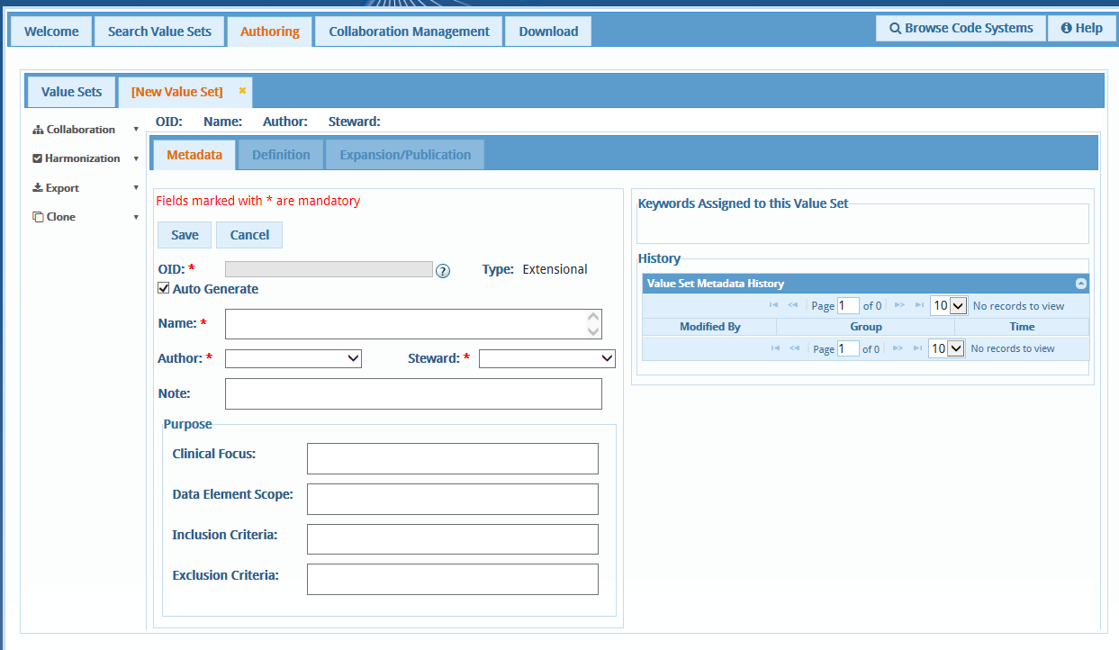
Figure 5 – VSAC Metadata tab for New Value Sets

  - The Definition tab contains the entered or imported draft code list (Figure 6).
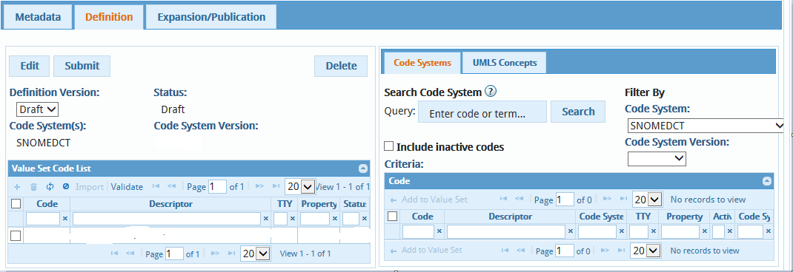
Figure 6 – VSAC Definition Tab for New Value Sets

- The author submits the value set to the steward for review and approval. [Value set status: ‘Proposed’]
  - Modifications can be made to value set based on review with steward and other stakeholders
- The steward approves the value set. [Value set status: ‘Approved’]
- The steward submits the value set to be published on a specific date using the Expansion/Publication tab. [Value set status: ‘Ready to Publish’]
- The VSAC application publishes the value set on the requested data. [Value set status: ‘Published’]. The value set is now available in the VSAC public repository.

Updating an Existing Value Set in VSAC
When necessary, existing value sets will be modified in VSAC.
- Verify that Author (Designated Terminologist) and Steward groups for the value set in VSAC are current and, if not, request that VSAC update the list.
- Using the VSAC Authoring Tool, select the value set to be updated by clicking on the OID. For previously published value sets, click the ‘New Version’ button. For draft value set, click the ‘Edit’ button.
  - Update any of the value set basic information (definition version, program, purpose etc.) as needed (Figure 7).
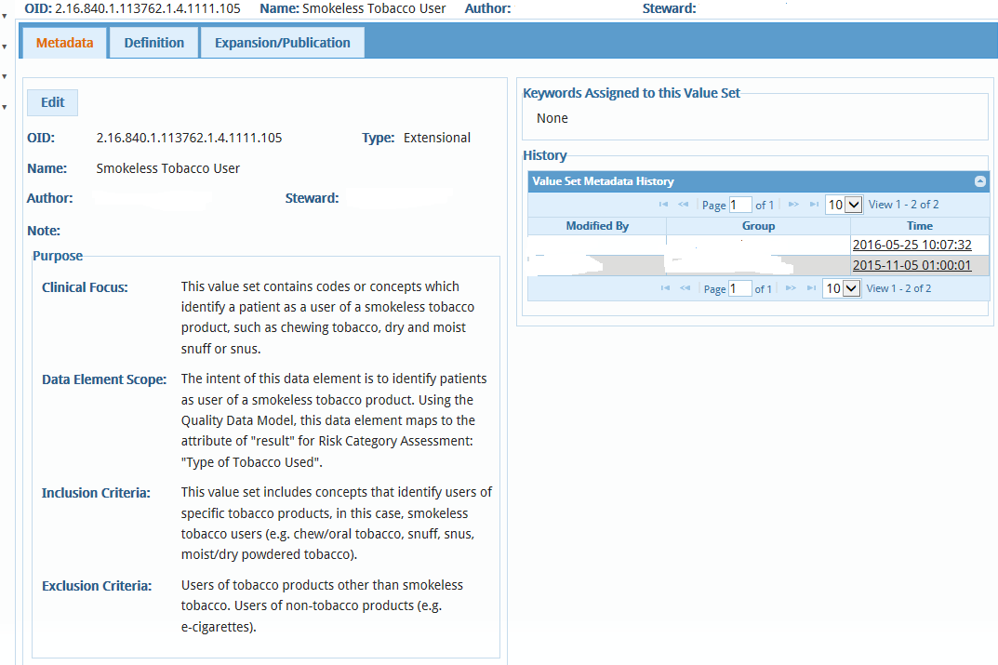
Figure 7 – VSAC Metadata tab for Existing Value Sets

  - Validate a previously published value set against an expansion profile to identify any invalid or inactive codes. Determine the appropriate Expansion profile to use for validation with the value set steward. Remove any inactive or invalid codes identified. Where possible, a remapped code may be identified to replace an inactive code, noting that this is only available in VSAC for the RxNorm, LOINC and SNOMED CT code systems (Figure 8).
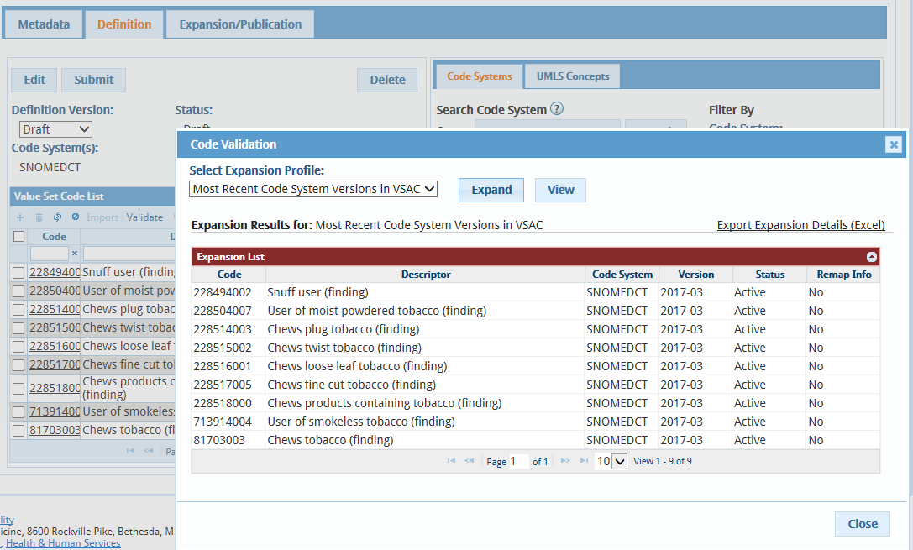
Figure 8 – Code Validation for Existing Value Sets
  - Determine the appropriate version of the code system for a new release of the value set.
    - Identify any new codes based on changes in definition or additional codes added to the code system that are consistent with value set definition based upon stakeholder review.
    - These changes can be identified through errata or comments from stakeholders.
  - Select the codes to remove from the code list and click on the trashcan icon at the top of the table.
  - Add individual codes to the code list by clicking on the + icon at the top of the table. Paste the code into the code field and verify the description and status. Import can be used if there is a long list of codes to add.
- Review the revised value set with the steward and obtain approval.
- The steward will identify the date for the new value set to be published (Figure 9).
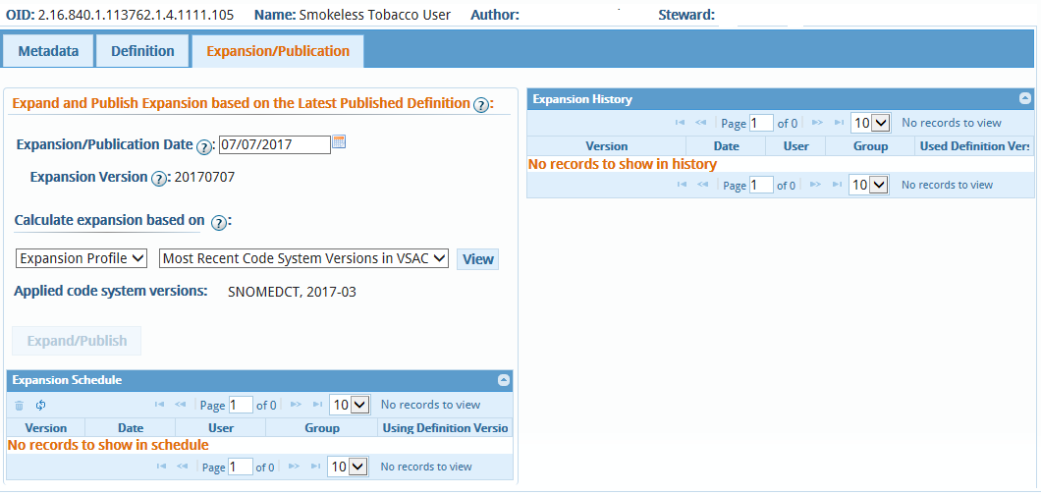
Figure 9 – Setting Expansion/Publication Date

- Reviewing Draft Value Sets in the VSAC Collaboration Tool
This section presupposes that all value set reviewers will have current UMLS user credentials, although authoring permissions are not required to use the VSAC Collaboration Tool.

Collaboration Site Creation
A VSAC Collaboration site will be created to present draft value sets and collect reviewer comments.
- The project team terminologist uses the ‘Custom Method’ to define a new Value Set Collaboration Review site in the VSAC Collaboration Tool that collects the draft value sets for review.
- The terminologist makes sure the site is set to ‘Public’ (the default ‘Visibility’ setting) so that reviewers can access the site.
- The terminologist adds introductory text providing a basic overview and guidance to the reviewers.
- The terminologist publishes the value set details to the set and ensures that the draft value sets are available for review.

Collaboration Site Distribution and Stakeholder Notification
The terminologist posts the appropriate stakeholder notification emails to the Stakeholder list serves (and other stakeholder groups as appropriate). This notification email will include:
- An overview of the draft value sets for review
- The URL of the draft value set Collaboration site
- Basic instructions on logging in with NLM credentials
- The time period for draft value set review
- Basic instructions on creating a discussion thread for comments on a value set (by referencing the VSAC Collaboration User's Guide)
- Basic instructions for creating a comment (by referencing the VSAC Collaboration User's Guide)

Draft Value Set Review
This step corresponds with Step 7, Review/Publish Changes in VASC, outlined in the main portion of this document. The stakeholder groups can use the Discussion Threads dashlet on the VSAC Collaboration Tool site for discussion and reconciliation of value set issues, as outlined in the VSAC Collaboration User's Guide.

User documentation is available at the VSAC Support Center (https://www.nlm.nih.gov/vsac/support/index.html).
UMLS licenses can be requested at: https://uts.nlm.nih.gov/license.html.
Complete documentation is available at: https://www.nlm.nih.gov/vsac/support/vsaccollaboration/index.html.
Ibid.

