[HL7_DAM_SPECIMEN_R2_INFORM_2017May]



**HL7 Domain Analysis Model: Specimen, Release 2**

May 2017

**HL7 Informative Ballot**

**Sponsored by:  
Orders and Observations Work Group**

**Clinical Genomics Work Group**

Copyright © 2015 Health Level Seven International ® ALL RIGHTS RESERVED. The reproduction of this material in any form is strictly forbidden without the written permission of the publisher. HL7 and Health Level Seven are registered trademarks of Health Level Seven International. Reg. U.S. Pat & TM Off**.**

Use of this material is governed by HL7's [**IP Compliance Policy**](http://www.hl7.org/legal/ippolicy.cfm?ref=nav).

**IMPORTANT NOTES:**

HL7 licenses its standards and select IP free of charge. **If you did not acquire a free license from HL7 for this document,** you are not authorized to access or make any use of it. To obtain a free license, please visit <http://www.HL7.org/implement/standards/index.cfm>.

**If you are the individual that obtained the license for this HL7 Standard, specification or other freely licensed work (in each and every instance "Specified Material")**, the following describes the permitted uses of the Material.

**A. HL7 INDIVIDUAL, STUDENT AND HEALTH PROFESSIONAL MEMBERS,** who register and agree to the terms of HL7’s license, are authorized, without additional charge, to read, and to use Specified Material to develop and sell products and services that implement, but do not directly incorporate, the Specified Material in whole or in part without paying license fees to HL7.

INDIVIDUAL, STUDENT AND HEALTH PROFESSIONAL MEMBERS wishing to incorporate additional items of Special Material in whole or part, into products and services, or to enjoy additional authorizations granted to HL7 ORGANIZATIONAL MEMBERS as noted below, must become ORGANIZATIONAL MEMBERS of HL7.

**B. HL7 ORGANIZATION MEMBERS,** who register and agree to the terms of HL7's License, are authorized, without additional charge, on a perpetual (except as provided for in the full license terms governing the Material), non-exclusive and worldwide basis, the right to (a) download, copy (for internal purposes only) and share this Material with your employees and consultants for study purposes, and (b) utilize the Material for the purpose of developing, making, having made, using, marketing, importing, offering to sell or license, and selling or licensing, and to otherwise distribute, Compliant Products, in all cases subject to the conditions set forth in this Agreement and any relevant patent and other intellectual property rights of third parties (which may include members of HL7). No other license, sublicense, or other rights of any kind are granted under this Agreement.

**C. NON-MEMBERS,** who register and agree to the terms of HL7’s IP policy for Specified Material, are authorized, without additional charge, to read and use the Specified Material for evaluating whether to implement, or in implementing, the SpecifiedMaterial, and to use Specified Material to develop and sell products and services that implement, but do not directly incorporate, the Specified Material in whole or in part.

NON-MEMBERS wishing to incorporate additional items of Specified Material in whole or part, into products and services, or to enjoy the additional authorizations granted to HL7 ORGANIZATIONAL MEMBERS, as noted above, must become ORGANIZATIONAL MEMBERS of HL7.

Please see <http://www.HL7.org/legal/ippolicy.cfm> for the full license terms governing the Material.

***Acknowledgements***

**Orders and Observations Work Group Co-Chairs:**

Lorraine Constable, Canada

Robert Hausam, USA

Hans Buitendijk, USA

Ken McCaslin, USA

Patrick Loyd, USA

Riki Merrick, USA

John David Nolen, USA

**Modeling/Project Facilitators:**

Robert Hausam, Hausam Consulting, USA

Lorraine Constable, Constable Consulting, Canada

**Project Facilitators:**

Lorraine Constable, Constable Consulting, Canada

Riki Merrick, Vernetzt, LLC, USA

**Publishing Facilitators:**

Lorraine Constable, Canada

**Domain Experts:**

Joyce Hernandez, Joyce Hernandez Consulting, LLC, USA

Mukesh Sharma,

Raj Dash, Duke

**Terminology:**

Robert Hausam, Hausam Consulting, USA

**Project Work Group:**

|  |  |  |
| --- | --- | --- |
| Gabriel Almeida | Rob Hausam | Cindie Robertson |
| Rita Altamore | Joyce Hernandez | Dmytro Rud |
| Hans Buitendijk | Mark Jones | Phil Pochon |
| Jim Case | Joan Knapp | Lisa Schick |
| Lorraine Constable | Helmut Koenig | Sandra Spiewak |
| Deb Dasgupta | Jay Lyle | Mollie Ullman-Cullere |
| Raj Dash  Lori Dieterle | Margaret Marshburn | Kathy Walsh |
| Ian Fore | Ken McCaslin | Ron Van Duyne |
| Jim Harrison | Riki Merrick | Diane Vaughan |
| Jovanka Harrison | JD Nolen | Serafina Versaggi |

|  |
| --- |
|  |

**Acknowledgements:**

We would like to acknowledge the efforts and support for development of this guide by the Association of Public Health Laboratories (APHL). APHL and this publication are supported by Cooperative Agreement # U60HM000803 from the Centers for Disease Control and Prevention (CDC) and/or Assistant Secretary for Preparedness and Response. Its contents are solely the responsibility of the authors and do not necessarily represent the official views of CDC and/or Assistant Secretary for Preparedness and Response.

Table of Contents

1 Introduction 8

1.1 Scope and goal of the project 8

1.2 Open Issues 8

2 Use Cases 9

2.1 Medical Research Use Case 9

2.1.1 Description 9

2.1.2 Preconditions 9

2.1.3 Use Case Sequence 9

2.1.4 Post Conditions 11

2.1.5 Actors 11

2.1.6 Use Case Scenario 11

2.2 Clinical Genomics Sequencing Use Case 11

2.2.1 Description 11

2.2.2 Preconditions 11

2.2.3 Use Case Sequence 11

2.2.4 Post Conditions 11

2.2.5 Actors 11

2.2.6 Use Case Scenario 11

2.3 Specimen Use Case for Isolate Representation 12

2.3.1 Description 12

2.3.2 Preconditions 12

2.3.3 Use Case Sequence Steps 12

2.3.4 Post Conditions 12

2.3.5 Actors 13

2.3.6 Use Case Scenario 13

2.4 Environmental Specimen Use Case 13

2.4.1 Description 13

2.4.2 Preconditions 15

2.4.3 Use Case Sequence 16

2.4.4 Post Conditions 16

2.4.5 Actors 16

2.4.6 Use Case Scenario 16

2.5 Specimen Origin Use Case 17

2.5.1 Description 17

2.5.2 Preconditions 17

2.5.3 Use Case Sequence 17

2.5.4 Post Conditions 17

2.5.5 Actors 17

2.5.6 Use Case Scenario 17

2.6 Interventional Imaging Use Case 17

2.6.1 Description 17

2.6.2 Preconditions 18

2.6.3 Use Case Sequence 19

2.6.4 Post Conditions 20

2.6.5 Actors 20

2.6.6 Use Case Scenario 20

3 Information Model 21

4 Attribute Definitions 22

4.1 Holder 22

4.2 Holder Parameters 23

4.3 Material 23

4.4 Non-Human Living Subject 24

4.5 Performer 24

4.6 Person 26

4.7 Specimen 26

4.8 SpecimenCollectionProcedure 29

4.9 Specimen Container 31

4.10 Specimen Container Parameters 33

4.11 Specimen Processing Activity 34

4.12 Storage Equipment 35

4.13 Subject 36

4.14 Subject Characteristics at Collection 36

List of Figures

Figure 1: Specimen Collection and Handling Activity Diagram for Medical Research Use Case 10

Figure 2: Domain Model for a Comprehensive Data Exchange and Data Element Organization of Environmental Samples provided with the Use Case 14

Figure 3: Sampling for one specimen for one container as provided with Use Case 19

Figure 4: Specimen Domain Model 21

Figure 5: Conceptual Data Types 22

Revision History

NOTE: Project ID 892

|  |  |  |  |
| --- | --- | --- | --- |
| Version | Date | Name | Comment |
| 1.0 | 3/23/2014 | Riki Merrick / Lorraine Constable | Document for ballot May 2014 |
| 1.1 | 3/25/2015 | Riki Merrick / Lorraine Constable | Document for publication post ballot reconciliation |
| 2.0 |  | Ron Van Duyne / Riki Merrick | Document for ballot May 2017 |

# Introduction

This document is intended to present the business requirements for data elements related to specimen for electronic data record systems (Electronic Health Record System, Personal Health Record System or Laboratory Information System).

## Scope and goal of the project

Several different domains in HL7 use specimen in their workflow with differing use case requirements. There is need for consolidation of all the requirements across the different use cases for all domains. The resulting domain analysis model (DAM) intends to represent all data elements, regardless of use in data exchange as long as they support workflow in its respective domain – input was provided from several sponsoring Work Groups (Orders and Observations, Clinical Genomics, Interventional Imaging and Anatomic Pathology).

As part of this analysis a review of Specimen V3 models as well as specimen related segments in V2 is included and specific emphasis was placed on support for the Specimen Identifier formats as further established by the Anatomic Pathology Work Group. This work used as its starting point the National Cancer Institute Life Sciences DAM.

## Open Issues

For the model:

1. For the StorageEquipment class:
   1. Is there a need to relate specific storage conditions for each instance of the equipment?
   2. Are the storage conditions for each specimen type defined somewhere, and if so, do they need to be referenced for the instance?
2. For the Specimen class:
   1. Several dates related to specimen processing and where best to capture these:
      1. SpecimenReceivedDate
      2. SpecimenExpirationDate
   2. Where best to capture SpecimenAppropriateness as this evaluation is dependent on the test requested
3. For the PerformedSpecimenCollection class:
   1. RepetitionNumber is defined as number of collection attempts, but is there a need to add a PositionInSeries attribute to indicate for example: “second of five attempts”?
4. For the SubjectCharacteristicsAtSpecimenCollection class:
   1. Question on where to place this class as these are often related to the test requested as well as the type of specimen submitted
5. For the Container and Holder classes:
   1. How to resolve the timing attributes here – should we add just EffectiveTime or are others like Duration also needed?

# Use Cases

Besides relying on the already developed HL7 artifacts, like the SPM segment in V2.x and the Specimen CMET in V3, we collected the following use cases as the basis for creating the domain analysis model:

1. [Medical Research Use Case](http://wiki.hl7.org/images/9/99/Specimen-Core_Model_Diagram_and_Medical_Research_Use_Case_Process_Flow.xls)
2. [Clinical Genomics Sequencing Use Case](http://wiki.hl7.org/index.php?title=Use_Cases_to_Consider_in_Specimen_CMET_-_from_CG_ClinSeq.doc)
3. [Specimen Use Case for Isolate Representation](http://wiki.hl7.org/index.php?title=Specimen_Use_Case_for_Isolate_Representation)
4. [Environmental Specimen Use Case](http://wiki.hl7.org/index.php?title=Specimen_Use_Case_for_Environmental_Specimen)
5. Specimen Origin Use Case
6. Interventional Imaging Use Case

The following use cases were submitted in order to evaluate if existing HL7 artifacts already covered some of the data needs identified by these use cases as well as to analyze relationships between collected attributes as well as between classes. Use cases submitted either expanded the previously covered workflow steps and their related observations into more details, or extended the subjects from whom specimen are collected and related information needed to be captured. These use cases are further elaborated in subsequent sections.

## Medical Research Use Case

### Description

The research laboratory receives a clinical specimen for research purposes. Often there are several processing steps required prior to performing the actual testing. In order to properly interpret the results at a later time and ensure comparability to other similar results under the same research protocol, all processing steps need to be recorded and identified. Every derived specimen needs to be individually identifiable, while retaining the relationship to its predecessors.

Once a specimen has been collected, it may be stored, transported (as from the site to the lab), or divided into smaller, “child” specimens; or it may undergo an extraction process that produces one or more specimens of different types from the original, which are also considered “child” specimens. Its physical properties, condition, and quality may be collected. The same is true for any specimens obtained from the original “parent” specimen through aliquoting or extraction, and for any specimens obtained from them, and so on.

Eventually nucleic acid (DNA or RNA) may be extracted. This constitutes a genetic sample, which may yet undergo further handling or be experimented upon directly.

### Preconditions

None

### Use Case Sequence

The activity diagram below represents the processing steps.

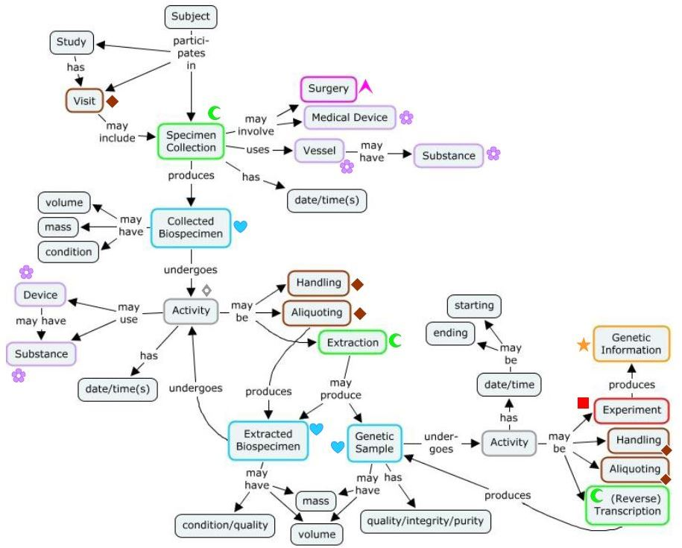

Figure 1: Specimen Collection and Handling Activity Diagram for Medical Research Use Case[1]

### Post Conditions

Not provided

### Actors

Research Laboratory

### Use Case Scenario

Not provided

## Clinical Genomics Sequencing Use Case

### Description

The purpose of this case is to describe the workflow needed for use in clinical genomics testing. Unique to this use case is the requirement for explicate identification of 1 or more specimens to be used in laboratory analysis. This likely necessitates the identification of specimen groups (i.e. separate specimens and associated derivatives) originating from the same patient/subject or related patients/subjects. Derivatives which may be analyzed from the various testing scenarios described in the use cases below include: DNA, RNA, and Protein.

### Preconditions

None

### Use Case Sequence

No Sequence Submitted

### Post Conditions

Separate specimens and associated derivatives originating from the same patient/subject or related patients/subjects have been prepared and are properly identified with specimen groups.

### Actors

Genomics Laboratory

### Use Case Scenario

In particular the following use case subtypes need to be captured:

1. Germline testing for biomarkers/mutations (usually inherited)
2. Tumor testing for somatic (tumor specific biomarkers/mutations)
   1. Matched specimens for germline and somatic analysis, where comparison will result in the identification of tumor specific mutations/biomarkers
   2. Tumor specimen without a matched germline specimen, where mutations/biomarkers are believed to be specific to tumors.
3. Pediatric testing for biomarkers/mutations causal to rare early childhood conditions
   1. Matched specimens of patient and maternal and paternal specimens, where comparison aids in identification of original biomarkers/mutations within the patient
4. Prenatal testing which may be reported on the maternal medical record and should be identified as separate from germline testing
   1. Often have matched fetal and maternal specimens for analysis
5. Infectious disease testing, where the biomarker/mutation identified within the disease causing organism is reported into the patient medical record following similar data standards as used for other testing scenarios above.
6. Microbiome analysis of the patient
   1. Includes analysis of microorganisms living in the patients gastrointestinal tract or Genitourinary system

## [Specimen Use Case for Isolate Representation](http://wiki.hl7.org/index.php?title=Specimen_Use_Case_for_Isolate_Representation)

### Description

Public Health Labs often receive isolates submitted for reference testing. The specimen type for that ordered test is the isolate, but information about the original clinical sample the isolate was grown from is important, so it also needs to be conveyed. A related use case is the testing of nucleic acid extracted from a sample, either submitted that way, or processed at the lab. Where would the following attributes about that original specimen be conveyed?

Not all of these would be required every time:

1. Original clinical specimen type (at minimum)
2. Original clinical specimen source site
3. Original clinical specimen collection method (if important)
4. Original clinical specimen additives / transport media (if important)

### Preconditions

Clinical sample has been submitted and a derived specimen has been created for submission to another lab for further testing.

### Use Case Sequence Steps

1. A clinical sample is submitted to the testing laboratory.
2. The testing laboratory provides testing on the clinical sample and in the process it creates a derived specimen.
3. The testing laboratory does not have the capacity to complete testing on the derived specimen.
4. The derived specimen is forwarded to the reference laboratory for further testing.
5. The reference laboratory receives the derived specimen and all information required to properly interpret the requested test.
6. The reference laboratory completes testing and provides the result to the testing laboratory, who forwards it to the original ordering provider.

### Post Conditions

1. Testing on the derived specimen is completed by the reference laboratory.
2. The result is sent to the testing laboratory.
3. The testing laboratory reports the results of its own testing along with the results from the reference lab to the original ordering provider.

### Actors

Testing laboratory

Reference laboratory

### Use Case Scenario

Patient John Q. Doe, a 45 year old white Hispanic male is seen by Dr. Mark A. Jones for severe diarrhea, who collects a stool sample and sends it to his usual testing laboratory, ACME Laboratory. During the testing process ACME Laboratory isolates Salmonella from the stool specimen and sends the isolate on the state Public Health Laboratory, where it is identified as *Salmonella enterica subspecies enterica*. The state Public Health Laboratory does not have the capacity for further subtyping and forwards the isolate to the Centers for Disease Control and Prevention’s National Salmonella Reference Laboratory for identification and subtyping.

## [Environmental Specimen](http://wiki.hl7.org/index.php?title=Specimen_Use_Case_for_Environmental_Specimen) Use Case

### Description

Public Health Environmental samples cover a broad spectrum of programs, matrixes, and methods. This spectrum continues to expand frustrating efforts to harmonize data elements for both the data generator and the data consumer. When defining the data elements that are necessary to characterize environmental samples for submission to a Public Health Laboratory it is useful to take a step back and seek opportunities to define these data elements in a such a way that they are agnostic to programs, matrixes, and methods and provide the ability to expand. Such an approach also makes data exchange between sample submissions easier to map and harmonize. Starting with a domain model that first looks at the organization of data elements is one approach.

As an example, ***Figure 2*** is a domain model used for data exchange and data element organization for public and private health laboratory sample submittal and collection of results for environmental emergency response. This domain model is more inclusive than needed for this discussion, since this domain model also includes data elements associated with sample analysis and results, but the specimen aspects were used as input into our domain Analysis Model.

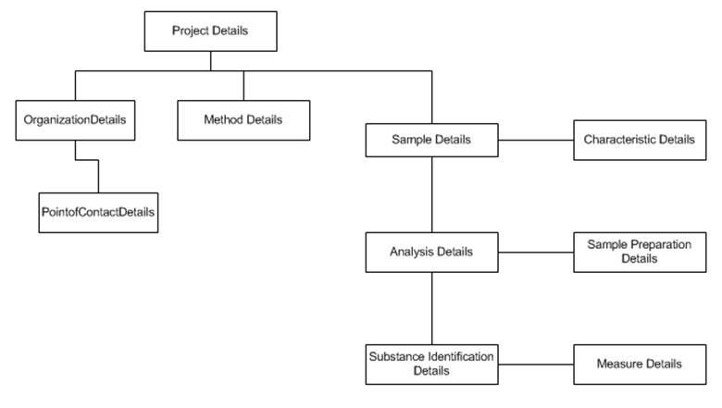

Figure 2: Domain Model for a Comprehensive Data Exchange and Data Element Organization of Environmental Samples provided with the Use Case

At this time, the discussion is focused on the data elements associated with sample submittal; an abbreviated domain model is appropriate.

Listed below are data element groups with example data elements that reflect multiple programs, matrixes (referred to as specimen type in the clinical domain), and methods associated with environmental health sample submissions.

For consideration in the DAM we are mostly interested in items #1, #2, #3, and #4. Some of the elements included in the DAM can also be used to address chain of custody requirements (#7).

1. Sample Collection Information
   1. Unique Sample Identifier supplied by Sampler; if a regulatory sample the sample license or regulatory identifier for the sample = format of ID plus assigning authority
   2. Sample Matrix (soil, water, air) = coded format with a sub matrix to reflect additional information as separate matrix modifier = coded format or text
      1. E.g. for water: well, lake, river, reservoir
      2. E.g. for soil: sand, clay, humus, landfill
      3. E.g. for food: fresh, cooked, commercial, home-made, fermented, pickled
   3. Sample Type to reflect the growing interest to capture measurement of quality objectives used for data validation such as:
      1. Test sample
      2. Field Spike and Laboratory Spike
      3. Field Blank and Laboratory Blank
      4. Field Duplicate and Laboratory Duplicate
      5. sampler/requestor name = name format
      6. date collected (range) = date/time format, include start and end date time, if applicable
      7. additional information specific to the program the sample is collected for
2. Sample Subject Information
   1. Type of Object, if applicable (for example the medical device) = coded format
   2. Manufacturer = text format
   3. Model = text format
   4. Lot Number = text format
   5. Service Date (or Prepared Date for food) = date/time format
   6. Expiration Date = date/time format
   7. Relationship to Human Sample = ID and assigning authority format (or name format?)
3. Sample Location
   1. GIS
   2. Text Location = address format (street, town, state, zip etc)
   3. Name or Identifier for the location (e.g. well ID, or name of lake) = format of ID and assigning authority or name (or would this be the sample subject?)
   4. Additional Information about the location of the sample (e.g. shore of the lake, close to house, playground) = text format
   5. Coordinates of sample collection (including depth)
4. Sample Characteristics that may affect analysis
   1. pH = number and units format
   2. Turbidity
   3. Temperature = number and units format
   4. Preservative = coded format
   5. Sample container = coded format
   6. Sample Batch Identifier = ID format with assigning authority
   7. Number of Samples in the Batch = number format
5. Sample Analysis Requested
   1. Sample Method = coded format
   2. Sample Results Point of Contact = name format and possibly ID format with assigning authority
   3. Other information such as turnaround time, requested detection limits, result data formats, data report format, etc.
6. Chain of Custody
   1. Chain of Custody Identifier needed = Boolean – if checked, then:
      1. Time Sample Delivered to Lab = date/time format
      2. Any other Sample Collectors = name format and possibly ID format with assigning authority
      3. Additional Sample Identifier = ID format with assigning authority

### Preconditions

None

### Use Case Sequence

No sequence submitted

### Post Conditions

None

### Actors

1. Organizational Requestor Type
2. Homeowner
3. Regulatory Program Associated with sample
4. FDA Program
   1. eLexnet (https://www.elexnet.com/elex/login/elexnethome.jsp)
5. EPA Program
   1. Safe Drinking Water Information System SDWIS (http://water.epa.gov/scitech/datait/databases/drink/sdwisfed)
   2. Air Quality System AQS (http://www.epa.gov/ttn/airs/aqsdatamart/)
   3. National Pollutant Discharge Elimination System NPDES (http://cfpub.epa.gov/npdes/home.cfm?program_id=45)
6. Centers for Disease Control and Prevention CDC
   1. LRN-C
7. Environmental Public Health Tracking
8. Environmental Childhood Lead
9. Public Health Environmental Laboratory

### Use Case Scenario

1. Water testing:
   1. Surface water testing for coliform bacteria:

Every month the Public Health Laboratory receives water samples collected from the local lake that is used as a swimming facility during the summer and determines the number of coliform bacteria in order to evaluate, if the lake is still safe for public use.

* 1. Well water testing for toxic contaminants:
     + 1. A homeowner collects water from a well to check for contaminants to determine, if it is still safe to drink.
       2. As part of the Safe Drinking Water Act all public water agencies have to regularly submit samples from their public water supply for contaminants testing

1. Soil sampling:
   1. Testing for lead in soil:

After an elevated blood lead level is reported to the Public Health Agency a case worker collects soil samples at the playground of the child care center and at the home of the child. These soil samples are then tested to determine the lead content to help locate the source of the lead contamination.

1. Environmental Swab
   1. Routine Infection Control:

As part of infection control the laboratory performs routine swabs of hospital equipment used in the Intensive Care Unit and sends them to the laboratory for culture.

1. Food
   1. A patient has been diagnosed with Salmonella typhi and this result has been reported to the Public Health Agency. A case investigation is started and based on the interview with the patient several food items are selected as possible sources and are sent to the Public Health Laboratory for testing.

## [Specimen Origin](http://wiki.hl7.org/index.php?title=Specimen_Use_Case_for_Environmental_Specimen) Use Case

### Description

Public health laboratories that handle a variety of sample types, not just human clinical samples, need an easy was to identify the category of specimen, also referred to as origin. As demonstrated in the Environmental Specimen Use case described above, the data elements required to be provided in order to properly interpret test results differ quite considerably from those needed for clinical samples depending on the category of specimen submitted.

### Preconditions

Sample collected from human or non-human origin.

### Use Case Sequence

N/A

### Post Conditions

Data related to specimen clearly indicates the origin of the specimen.

### Actors

Public Health Laboratory

### Use Case Scenario

See Environmental Specimen Use Case 2.4.6

## Interventional Imaging Use Case

### Description

Specimens may be collected as part of an interventional imaging procedure and then sent into the anatomic pathology workflow.

The specimen model needs to accommodate the identification of

* Case
* Part
* Block
* Slide or similar entities derived by processing steps – each can be generalized as “Container”.

Digital Imaging and Communications in Medicine (DICOM) [2]defines formal attributes for the identification and description of the specimen that is subject of a DICOM image – these are necessary to understand and interpret the image. They cover the following classes:

* Specimen
* Container
* Specimen Collection
* Specimen Sampling
* Specimen Processing
* Specimen Ancestor(s)

### Preconditions

None

### Use Case Sequence



Figure 3: Sampling for one specimen for one container as provided with Use Case[3]

***Figure 3*** illustrates the transition of a surgically removed specimen for anatomic pathology work up and the steps followed from removal from body to microscopic examination on a slide. The ***Use Case Scenario*** section 2.6.6 describes each of the steps in more detail.

### Post Conditions

Components of a single case are correctly identified at a specimen, part, block and section level.

### Actors

Surgeon

Interventional Radiology Staff

Anatomic Pathology Staff

### Use Case Scenario

Interventional Imaging is part of the anatomical pathology workflow when examining specimen.

1. Case: As part of the typical anatomic pathology workflow all samples removed in a single collection procedure, be they biologic (e.g. tissue) or non-biologic (e.g. orthopedic hardware) are considered a single “Case” and given a single identifier, often referred to as an accession.
2. Specimen = Part: The surgeon may label and send one or more discrete collections of material (specimens) to pathology for analysis, which are expected to be both identified as being part of the “Case”, while at the same time being treated as a separate entity as well. Each “Part” is a logical component of the laboratory workflow and is managed separately.
3. Blocks = Each “Part” can be further processed into smaller sections called “Blocks” treated with different materials (e.g. embedded in a paraffin block or epoxy resin) for further examination.
4. Sections = This “Block” can be further sliced into thin “Sections” and one or more “Sections” will be placed on slides for histological examination.

# Information Model

Analysis of the described use cases and activity flows resulted in the following conceptual information model.

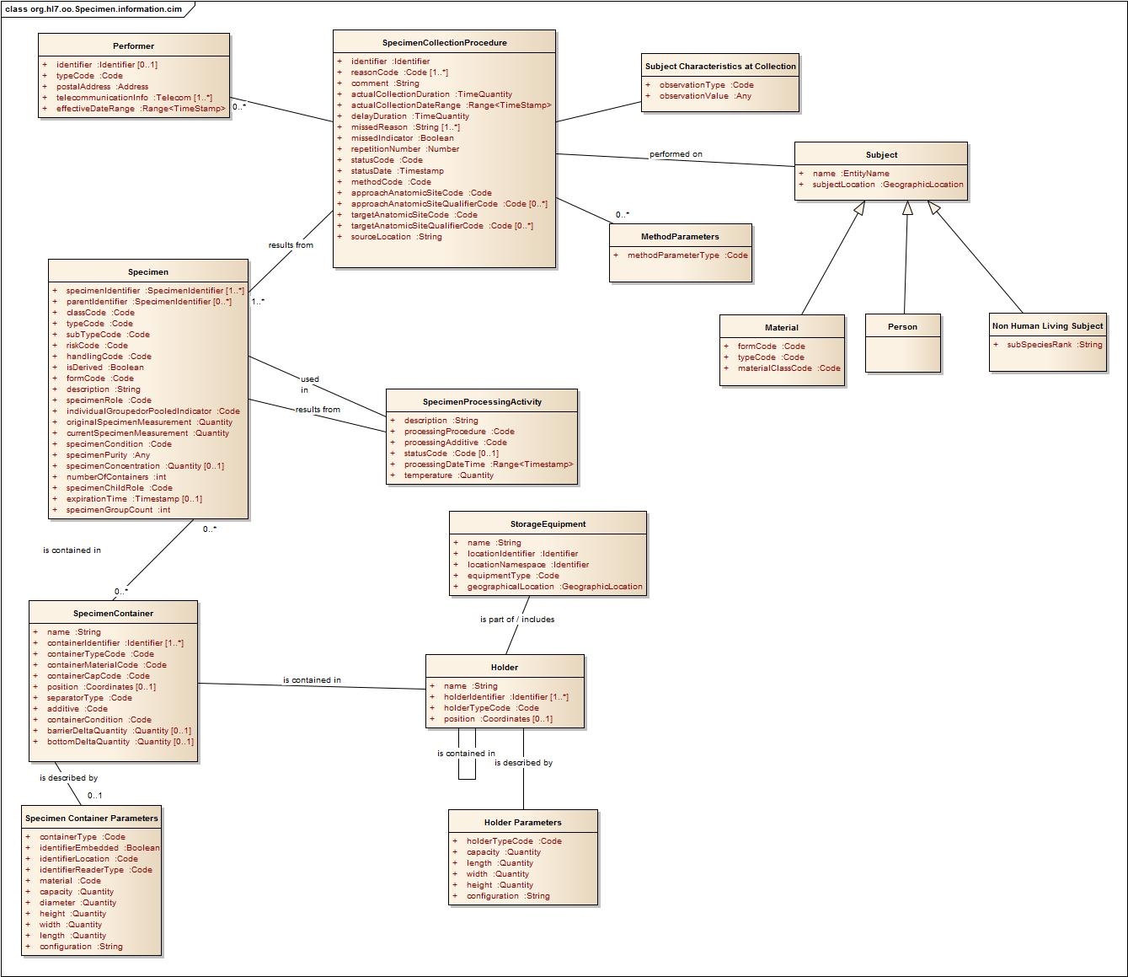

Figure 4: Specimen Domain Model[4]

The attributes in the above model use the following conceptual datatypes:

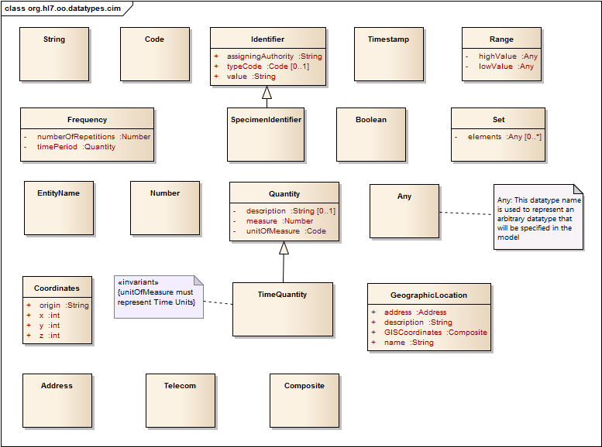

Figure 5: Conceptual Data Types

Definitions of the classes and attributes are documented in subsequent sections.

# Datatype Attribute Definitions

## Address

DEFINITION: Formal representation of a location of a person, place or thing.

## Any

DEFINITION:

## Boolean

DEFINITION: A binary variable, having two possible values called “true” and “false.”.

## Code

DEFINITION: A sequence of characters (the code) that uniquely identifies the item being referenced in a defined system.

## Composite

DEFINITION:

## Coordinates

DEFINITION: A group of numbers used to indicate the position of a point, line, or plane.

ATTRIBUTES:

| **Name** | **Type** | **Cardinality** | **Definition** |
| --- | --- | --- | --- |
| origin | String | 0..1 | The starting point for the dimension measurements. |
| horizontal dimension (x) | Number | 0..1 | . |
| Vertical dimension (y) | Number | 0..1 |  |
| Vertical dimension (z) | Number | 0..1 |  |

## EntityName

DEFINITION: Linguistic designation of a thing with distinct and independent existence.

## Frequency

DEFINITION: The rate at which is repeated over a particular period of time or in a given sample.

## GeographicLocation

DEFINITION: The physical place or position of a person, place or thing.

ATTRIBUTES:

| **Name** | **Type** | **Cardinality** | **Definition** |
| --- | --- | --- | --- |
| address | Address | 0..1 |  |
| GIS coordinates |  | 0..1 |  |
| Description | String | 0..1 |  |

## Identifier

DEFINITION: The alphanumeric sequence, with metadata about the entity that created it and if needed its typecode, that uniquely defines the organization the performer is acting on behalf of.

Attributes:

| **Name** | **Type** | **Cardinality** | **Definition** |
| --- | --- | --- | --- |
| value | ST | 1..1 | The alphanumeric sequence that sometimes uniquely, sometimes not uniquely, defines the entity (either an attribute in a class or a class itself) torganization the performer is acting on behalf of.  EXAMPLE(S): Performer.associatedOrganization(Identifier).value is the alphanumeric sequence that uniquely defines the organization the performer is acting on behalf of.  Specimen.identifer is The alphanumeric sequence that  ADD A FEW MORE? |
| assigningAuthority | ST | 1..1 | Identifies the entity that assigned the identifier string in this datatype.  EXAMPLE(S): An identifier might be assigned to an organization by another organization, for example a laboratory is assigned a CLIA number by a regulatory agency. |
| typeCode |  | 0..1 | A coded value specifying the kind of entity identifier.  EXAMPLE(S):  For a subject it might be a hospital record number, medical record number, donor registry number etc..  For a specimen it might be a specimen identifier, which is used for individual specimen, or a specimen group number, which identifies multiple specimen that all belong to the same set.  For a performer it might be the employee number, the National Provider ID, etc..  For some classes there is only one type code, for example for organizations, containers, holders or storage equipment, etc.. |

## Number

DEFINITION: A sequence of digits.

## Range

DEFINITION: The difference between the lowest and highest values of a given measure.

NOTES: It can be combined with Quantity, TimeStamp

## Set

DEFINITION:

## String

DEFINITION: A sequence of symbols or digits (alphanumeric).

## Telecon

DEFINITION:

## TimeQuantity

DEFINITION: A measure of time with variable units representing concepts of time.

EXAMPLE(S): 60 minutes, 24 hours, one day, one week etc

NOTES: This uses the Quantity datatype where the Unit of measure is restricted to codes representing concepts of time.

## TimeStamp

DEFINITION:

## Quantity

DEFINITION: A measure with unit.

EXAMPLE(S): length, width, temperature, weight

Attributes:

| **Name** | **Type** | **Cardinality** | **Definition** |
| --- | --- | --- | --- |
| number | Number | 1..1 | A concept from mathematics, used to count or measure. |
| Unit of measure | Code | 0..1 | Coded representation of the property of the thing being measured. |

# Class Attribute Definitions

## Holder

DEFINITION: Physical object that contains a specimen container or another holder. For instance, a rack may contain trays and trays may contain specimen tubes.

Attributes:

| **Name** | **Type** | **Cardinality** | **Definition** |
| --- | --- | --- | --- |
| name | String | 1..1 | A non-unique textual identifier for the holder.  EXAMPLE(S): tray, rack, cassette |
| holderIdentifier | Identifier | 1..* | The alphanumeric sequence, with metadata about the entity that created it and if needed its typecode, that uniquely defines the instance of the holder.  NOTE: This is the identifier that is included in the label attached to a holder. Label can be linear or 2 dimensional bar code, RFID. |
| holderTypeCode | Code |  | Coded representation of the holder type in which specimen containers are contained.  Example(s): model number of the tray or rack |
| Position | Coordinates | 0..1 | Coordinates of holder relative to other holder or storage equipment.  Example(s): third shelf in fridge A |

## Holder Parameters

DEFINITION: Description of the physical measures which describes the physical parameters or space occupied the measure or the amount which it may contain.

Note: Attributes describing the type of holder as needed mostly for automation.

Attributes:

| **Name** | **Type** | **Cardinality** | **Definition** | |
| --- | --- | --- | --- | --- |
| holderTypeCode | Code |  | Coded representation of the categorization of a holder. | |
| capacity | Quantity |  | Designed maximum number of containers. | |
| length | Quantity |  | The longest horizontal measurement of an object. | |
| width | Quantity |  | Distance from side to side, measuring across the object at right angles to the length. | |
| height | Quantity |  | The measurement of vertical distance. | |
| configuration | String |  | Defines the row and column layout for the container.  Example(s): A rack may be a 18x8 configuration | |

## Location

DEFINITION:

Attributes:

| **Name** | **Type** | **Cardinality** | **Definition** |
| --- | --- | --- | --- |
| geographicLocation |  |  |  |

## Material

DEFINITION: Any thing that has extension in space and mass, of non-living origin. Purpose of testing is not to diagnose for its own sake but for the sake of others.

Example(S): Food, Water, Air

Attributes:

| **Name** | **Type** | **Cardinality** | **Definition** | |
| --- | --- | --- | --- | --- |
| formCode | Code | 1..1 | Coded representation specifying the state and nature of the material.  Example(s): Powder, Liquid, Gas | |
| typeCode | Code | 1..1 | Coded representation of lower level categorization of the material.  Example(s): soil, water, peanut butter, air | |
| materialClassCode | Code |  | Coded representation of the high level categorization of the material.  Example(s): environmental, food, biologic product, medical devices | |
| description | String | 0..1 | The textual representation of the material. | |

## Non-Human Living Subject

DEFINITION: Any living organism that is not species *homo sapiens sapiens*.

Example(s): mice, rabbits, plants, microorganisms

Attributes:

|  |  |  |  |
| --- | --- | --- | --- |
| **Name** | **Type** |  | **Definition** |
| subSpeciesRank | Code | 1..1 | Any description of a sub-population of organisms below the species level.  Example(s): Influenza A, German Shepherd, tabby cat |

## Performer

DEFINITION: The entity (person, machine) that collects a specimen EXAMPLE(S): Phlebotomist, nurse, physician, scientist, laboratory testing device

Attributes:

| **Name** | **Type** | **Cardinality** | **Definition** |
| --- | --- | --- | --- |
| identifier | Identifier |  | The alphanumeric sequence that uniquely defines the Entity (person, machine etc.) that collected a Specimen.  EXAMPLE(S): UDI from the FDA GUDID, employee ID, provider number |
| typeCode | Code |  | Coded representation of the categorization of the entity that is the performer.  Example(s): person, machine |
| postalAddress | Address | 0..1 | The location (address, postal code) for the performer. |
| telecommunicationInformation | Telecom |  | The electronic contact information of the performer  Example(S): phone number, IP address, email.  NOTE: This is a repeating attribute – if information about equipment and its responsible person is needed, create two instances. |
| effectiveDateRange | Range |  | The date/time that the performer is allowed to act in that role in the system. |
| associatedOrganizationName | String | 0..1 | A non-unique textual identifier for the organization that the performer is associated with.  EXAMPLE(S):  NOTES:  This can be the collecting laboratory, the collecting doctor's office or a draw station. etc. |
| associatedOrganizationIdentifier | Identifier | 0..1 | The alphanumeric sequence, with metadata about the entity that created it and if needed its typecode, that uniquely defines the organization the performer is acting on behalf of. |

## Person

DEFINITION: Individual human subject, who can assume multiple roles over time.

Example: A person may be a patient for a period of time at a hospital or a provider on a different occasion.

## Product

DEFINITION: A material used in specimen processing.

EXAMPLE(S): additives, fixatives, or cell lines (e.g. HeLa, HEK-293).

Attributes:

| **Name** | **Type** | **Cardinality** | **Definition** |
| --- | --- | --- | --- |
| Name or typeCode |  |  | Textual representation of the product.  OR  Coded representation of the kind of material used |
| lotNumber | ST | 0..1 | A string using alphanumeric and special characters to identify a particular batch of the product. |
| expirationDate | TS | 0..1 | The date (and time), assigned by the manufacturer, on which the product should not be used. |
| ManufacturerName | ST | 0..1 | Textual representation of the entity that produced the material used in the processing activity. |

## Specimen

DEFINITION: A specimen is a substance, physical object, or collection of objects, that the laboratory considers a single discrete, uniquely identified unit that is the subject of one or more steps in the laboratory workflow.

Note: It may include multiple physical pieces as long as they are considered a single unit within the laboratory workflow.

Attributes:

| **Name** | **Type** | **Cardinality** | **Definition** | |
| --- | --- | --- | --- | --- |
| specimenIdentifier | Identifier | 1..* | The alphanumeric sequence, with metadata about the entity that created it and if needed its typecode, that uniquely defines the specimen.The alphanumeric sequence, with metadata about the entity that created it and if needed its typecode, that uniquely defines the specimen.  EXAMPLE(S):  NOTES: | |
| parentIdentifier | Identifier | 0..* | SpecimenIdentifier of the specimen from which the current specimen was derived | |
| classCode | Code |  | Coded representation of the general category of material or specimen.  Example(s): environmental, food, biologic product, medical devices  NOTE: Whether this attribute is covered by using a hierarchical terminology or separately is left for logical or implementation step. In the domain analysis model the goal was to highlight this attribute as something that needs to be considered. | |
| typeCode | Code |  | Coded representation of the precise nature of the entity that will be the source material for the observation.  Example(s): stool, tissue, blood, CSF | |
| subTypeCode | Code |  | Coded representation of lower level categorization of the specimen.  Example(S): In Clinical Genomics, need to identify specific subtypes such as somatic or germline samples | |
| riskCode | Code |  | This field contains any known or suspected specimen hazards  EXAMPLE(S): exceptionally infectious agent, blood from a hepatitis patient, BioSafetyLevel (BSL), flammable, radioactive | |
| handlingCode | Code |  | Coded representation of how the specimen and/or container need to be handled from the time of collection through the initiation of testing.  Example(s): keep frozen, do not allow contact with water | |
| isDerived | Boolean |  | A Boolean indicator to note that the current specimen is derived from another specimen.  NOTE: Derivation procedure will be indicated by the SpecimenProcessingActivity – processingProcedure code. Conformance Statement - if the "Is derived" flag is checked, the parentIdentifer attribute for this specimen (see second entry in this table) must be filled out. | |
| formCode | Code |  | Coded representation specifying the state and nature of the material.  EXAMPLE(S): solid, liquid, gas, tablet, ointment, gel | |
| description | String |  | Additional information specifically about the specimen.  EXAMPLE(S): size and appearance of tissue | |
| specimenRole | Code |  | Coded representation of the purpose of the sample as related to the analytical procedure being performed.  Example(S): A reference sample, proficiency sample, QC sample, clinical sample | |
| individualGroupedorPooledIndicator | Code |  | Coded representation of the type of sample.  Example(S): individual, grouped or pooled sample for example from a herd of cattle.  NOTE: May need to track the identifiers of pool constituents, and/or the group counts | |
| originalSpecimenMeasurement | Quantity |  | The initial volume, mass or size of the specimen. | |
| currentSpecimenMeasurement | Quantity |  | The amount of specimen currently available for use in further testing. | |
| specimenCondition | Code | 0..* | A mode or state of being that describes the nature of the specimen.  Example(S): hemolyzed, clotted  NOTE: This is specifically allowed to repeat, in case more than one condition needs to be captured. | |
| specimenPurity | Code |  | A numeric or coded value used to indicate freedom from contaminants of a given specimen.  Example(S): In Clinical Genomics will generally be numeric.  NOTE: This attribute is only needed in certain domains, for example in bio-banking. | |
| specimenConcentration | Quantity | 0..1 | Numeric value describing the abundance of the specimen constituent divided by the total volume of a mixture.  NOTE: This attribute is only needed in certain domains, for example in bio-banking. | |
| numberOfContainers | Quantity |  | Numeric value used to verify receipt of specimens. | |
| specimenChildRole | Code |  | Coded representation of the purpose or role of a derived specimen with respect to its parent.  Example(S): Aliquot, Block for tissue sections from a specimen or Slide from a block | |
| expirationTime | Date/Time | 0..1 | The date after which the specimen is no longer viable.  Example(S): Based on a time interval calculated from the collection time | |
| specimenGroupCount | Quantity |  | The number of individual specimens of a particular type represented by this instance of a specimen.  Example: Samples from 25 animals in a cattle herd are collected. | |
| RelatedOrderIdentifier | Identifier | 0..* | The alphanumeric sequence that defines the specimen that are collected to fulfill a specific order | |

## SpecimenCollectionProcedure

DEFINITION: The specific instance of the procedure in which the specimen was obtained.

EXAMPLE(S): blood draw, urine collection, nasopharyngeal swab, tissue biopsy

Attributes:

| **Name** | **Type** | **Cardinality** | **Definition** | |
| --- | --- | --- | --- | --- |
| ProcedureCode | Code | 1..1 | The activity that is performed to collect the specimen.  EXAMPLE(S): Finger stick, venipuncture, Biopsy, Bronchial alveolar lavage (BAL) (for specimen collection)  Open, laparoscopic (for cholecystectomy) | |
| Identifier | Identifier | 0..1 | The alphanumeric sequence with metadata about the entity that created it and if needed its typecode, that uniquely defines the instance of the Specimen Collection Event. | |
| reasonCode | Code | 1..* | A coded value specifying the motivation, cause, or rationale of a specimen collection activity.  EXAMPLE(S): routine requirement, drug reaction, infectious disease reporting requirement, on patient request, on provider request, to confirm or rule out a diagnosis | |
| Comment | String | 0..1 | Information which is entered regarding collection of a specimen.  NOTE: This should be information that is not able to be communicated in a structured format | |
| actualCollectionDuration | Duration | 1..1 | The span of time over which the collection of a specimen occurred.  EXAMPLE(S): 24 hours or 30 minutes.  NOTE: This may not be needed unless the specimen type requires collection duration. | |
| actualCollectionDateRange | Range<TimeStamp> | 1..1 | The actual begin and end collection date/time of the specimen.  NOTE: This may document a single date/time, when both start and end date have the same value, or could include a range as well as support ongoing activity, when no end dateTime is supplied. This is not expected for the specimen collection procedure, but supported by the datatype.  EXAMPLE(S): 24 hour urine would be represented as  start: 201309120700  end: 201309130700  A fingerstick will be represented as  start: 201309120700  end: 201309120700 | |
| delayDuration | Duration |  | The amount of time the collection was delayed from the requested date/time of the order. | |
| missedReason | String | 1..* | The reason why specimen collection was not completed for an Order. | |
| missedIndicator | Boolean | 1..* | Specifies that the specimen collection did not occur.  Example(s): The indicator is set to true, if the specimen collection event did not occur. | |
| repetitionNumber | Quantity |  | The number of times that a collection was attempted for the Order related to this collection. | |
| statusCode | Code | 1..* | The state of collection of a specimen.  EXAMPLE(S): Dispatched, Pending-Collection, Missed  NOTE: Order statuses are similar to collection statuses, but they are not the same. There can be multiple orders collected in the same container, and those orders can have different statuses. | |
| statusDate | Date/Time | 1..* | The date (and time) on which the status is assigned to the specimen collection activity. | |
| methodCode | Code | 1..1 | A coded value specifying the technique that is used to perform the procedure.  EXAMPLE(S): Finger stick, venipuncture, Biopsy, Bronchial alveolar lavage (BAL) (for specimen collection)  Open, laparoscopic (for cholecystectomy) | |
| approachAnatomicSiteCode | Code | 1..1 | A coded value specifying the body site, used to approach the target site during the collection procedure, if different from target site.  Example(s): Liver biopsy is obtained via a percutaneous needle, the approach site would be the point of entry of the needle. | |
| approachAnatomicSiteQualifierCode | Code | 0..* | Coded representation of modifying or qualifying descriptors about the approach site.  Example(s): left, right, ventral, caudal  NOTE: Whether this is pre-coordinated with approachAnatomicSite attribute is left up to the logical model, or even the implementation application. In the domain analysis model the goal was to highlight this attribute as something that needs to be considered. | |
| targetAnatomicSitePortionCode | Code | 0..* | A coded value specifying the arrangement or apportionment of the body (or a paired organ) that is a target site for a procedure.  EXAMPLE(S):  entire, single, segment, many  NOTES:  For entire or part of an organ or segment should use the appropriate SNOMED CT code from anatomic body structure hierarchy in SpecimenCollectionProcedure.targetAnatomicSite element  For left, right, upper etc use the proper code in the SpecimenCollectionProcedure.targetAnatomicSiteQualifierCode element  Use this element to quantify if single or multiple samples per site - value set to be determined | |
| targetAnatomicSiteCode | Code | 1..1 | The code representing the anatomical location from which the specimen was collected (if subject is a human or animal subject).  EXAMPLE(S): lung, liver, femur  Note: This element is not used for environmental specimens. | |
| targetAnatomicSiteQualifierCode | Code | 0..* | Coded representation of modifying or qualifying descriptors about the target source site.  Example(s): left, right, ventral, caudal  Note: This element is not used for environmental specimens.  Whether this is pre-coordinated with targetAnatomicSite attribute is left up to the logical model, or even the implementation application. In the domain analysis model the goal was to highlight this attribute as something that needs to be considered. | |
| sourceLocation | String |  | Description of the specific position or point in physical space from where the specimen was collected.  Example(s): left corner of table, depth of a soil sample  NOTE: Equivalent to targetAnatomicSite for non-living subjects. | |
| referencedProtocolIdentifier | Identifier | 0..1 | The alphanumeric sequence, with metadata about the entity that created it and if needed its typecode, that uniquely defines the instance of a protocol.  NOTE: For biospecimen best practices generally recommends referencing SOP | |
| referencedProtocolName | ST | 1..1 | The textual designation by which the used protocol is known.  NOTE: For biospecimen best practices generally recommend referencing SOP | |
| referencedProtocolDeviationComment | ST | 0..* | Description of the reasons or other important information to be captured about the changes in the specimen collection procedure from the prescribed protocol. | |
| referencedProtocolDeviationType | Code | 0..* | Codified representation of the type of change in the specimen collection procedure from the prescribed protocol. | |
| varianceTypeCode | Code | 0..1 | Primary kind of exception to protocol  Example(S): not collected / collect less than expected / inadequate specimen quality / | |
| varianceReasonCode | Code | 0..* | Reasons why an exception to the protocol occurred.  Example(s): quantity not sufficient / late procedure [and banking staff went home]) / Damaged / Debris, Dis-colored / Freezer Artifacts / Thawed, Hemolyzed, grossly / Hemolyzed, moderately / Hemolyzed, slightly /other and allow free text | |

## Specimen Container

DEFINITION: Physical object that touches and holds specimen.

EXAMPLES: slide, tube, box, jar

Attributes:

| **Name** | **Type** | **Cardinality** | **Definition** |
| --- | --- | --- | --- |
| name | String | 1..1 | A non-unique textual identifier for the specimen container.  EXAMPLE(S): screwcap jar, bloodtube, slide, parafin block |
| containerIdentifier | Identifier | 1..* | The alphanumeric sequence, with metadata about the entity that created it and if needed its typecode, that uniquely defines the instance of the container.  NOTE: This identifier is included in the label attached to a specimen container. Label can be linear or 2 dimensional bar code, RFID. Example(S): In Pathology a tissue specimen or part would have a Unique identifier and one or more blocks may result from a single part with each block having their own Unique Identifier. This would also accommodate clinical specimens such as CSF. |
| containerMaterialCode | Code |  | Coded representation of the material composition of the container.  Example(s): codes for glass, plastic, metal |
| containerCapCode | Code |  | Coded representation of the type of container cap. Container caps may be used to identify differences in container attributes to facilitate tracking and processing  Example(s): red top, tiger top, purple, blue |
| position | Coordinates | 0..1 | Coordinates of specimen container relative to the holder. |
| separatorType | Code |  | A material in a fluid collection container that facilities the separation of cellular or solid material from liquid.  Example(s): SST, buffy cell layer |
| additive | Code | 1..1 | Substances introduced in order to preserve, maintain or enhance the particular nature or component of the specimen.  Example(s): Formalin, Citrate, EDTA |
| containerCondition | Code |  | A textual note or description regarding discrepancies or anomalies observed about a container.  Example(s): Cap not sealed, label not firmly attached, tube received broken |
| identifierLocation | Code |  | Placement of the identifier on or in the container. |
| barrierDeltaQuantity | Quantity | 0..1 | Distance from the Point of Reference to the separator material (barrier) within the container in units specified below.  Example(s): Serum gel tube, tubes that are being centrifuged |
| bottomDeltaQuantity | Quantity | 0..1 | Thickness of the container at the bottom of the container.  Example(S): Adjustment to make to the drop distance based on the container parameter (tube height) and the thickness of the container wall at the bottom - idea is to not break the tip off the pipette. |

## Specimen Container Parameters

DEFINITION: Attributes describing the type of container as needed mostly for automation.

Attributes:

|  |  |  |  |
| --- | --- | --- | --- |
| **Name** | **Type** | **Cardinality** | **Definition** |
| ContainerTypeCode | Code |  | Coded representation of the categorization of a container.  Example(S): screwjar top, serum tube, slide |
| capacity | Quantity |  | The maximum amount of a substance or number of physical objects that a container can hold. Examples: For tubes this is draw volume, for tissue micro array slides it could be the number of wells. |
| length | Quantity |  | The longest horizontal measurement of an object. |
| width | Quantity |  | Distance from side to side, measuring across the object at right angles to the length. |
| height | Quantity |  | The measurement of vertical distance. |
| diameter | Quantity |  | The distance across a circle.  Applies only to cylindrical containers. |
| identifierEmbedded | Boolean |  | Boolean indicating if the identifier is placed inside the container material. |
| identifierLocation | Code |  | Placement of the identifier on or in the container, if identifier embedded is set to 'true'. |
| identifierReaderType | Code |  | Equipment needed to read the identifier on the container.  Examples: Barcode scanner, chip reader, if all else fails human |
| material | Code |  | Coded representation of the material composition (i.e. physical substance) of the container. |
| configuration | String |  | Defines the row and column layout for the container.  Example(S): Available positions for specimen on a slide (4 quadrant slide). |

## Specimen Move Activity

DEFINITION: Describes the attributes needed to track the change in location of a specimen.

Example(s): From one holder into another holed, from one lab section to another lab section, into storage

NOTE(S): Attributes in this class are optional and can be used as needed for the type of transaction being recorded, e.g. check-in can represent the intake of a new specimen using the “to position” attributes only, likewise check-out can represent a specimen being taken out of a container using only the "from position" attributes.

Attributes:

| **Name** | **Type** | **Cardinality** | **Definition** |
| --- | --- | --- | --- |
| varianceReasonCode | Code | 0..* | Reasons why an exception to the protocol occurred.  Example(s): quantity not sufficient / late procedure [and banking staff went home]) / Damaged / Debris, Dis-colored / Freezer Artifacts / Thawed, Hemolyzed, grossly / Hemolyzed, moderately / Hemolyzed, slightly /other and allow free text |
| varianceTypeCode | Code | 0..1 | Primary kind of exception to protocol  Example(S): not collected / collect less than expected / inadequate specimen quality / |
| FromEntity | Coordiantes  OR  GeographicalLocation | 0..1 | A reference to the coordinates that describe the location of the specimen in the previous holder / storage equipment before the move or the location from which the specimen was moved. |
| ToEntity | Coordiantes  OR  GeographicalLocation | 0..1 | A reference to the coordinates that describe the location of the specimen in the holder / storage equipment after the move or the location to which the specimen was moved. |
| PlacedIntoElementIdentifier | Identifier | 0..1 | Alphanumeric sequence that identifies the element, with metadata about the entity that created it and if needed its typecode, the specimen was moved to.  NOTE: In the case of storage equipment it references the locationIdentifer, in the case of a holder it references the holderIdentifier, in the case of a device it references the deviceIdentifier, in the case of a container it references the containerIdentifer |
| TakenFromElementIdentifier | Identifier | 0..1 | Alphanumeric sequence that identifies the element, with metadata about the entity that created it and if needed its typecode, the specimen was moved from  NOTE: In the case of storage equipment it references the locationIdentifer, in the case of a holder it references the holderIdentifier, in the case of a device it references the deviceIdentifier, in the case of a container it references the containerIdentifer |

## Specimen Processing Activity

DEFINITION: Description of procedure.

Attributes:

| **Name** | **Type** | **Cardinality** | **Definition** |
| --- | --- | --- | --- |
| Identifier | Identifier | 0..1 | The alphanumeric sequence, with metadata about the entity that created it and if needed its typecode, that uniquely defines the instance of a specimen processing activity. |
| description | String |  | Textual explanation of procedure. |
| processingProcedure | Code | 1..1 | Coded representation of a step in the procedure. |
| processingReasonCode | Code | 0..* | A coded value specifying the motivation, cause, or rationale of a specimen processing activity.  EXAMPLE(S): Stabilize the specimen, preserve the specimen for later clinical care testing, preserve specimen for research testing |
| processingAdditive | Code | 1..1 | Substance added to a specimen for preservation or to aid in the process as required by the procedure.  EXAMPLE(s): Anticoagulant, Separator, stabilizer |
| statusCode | Code | 0..1 | Coded representation of the state of the processing step in the procedure.  Example(S): completed, in progress, scheduled |
| processing DateTime | Range<TimeStamp> | 1..1 | The actual begin and end collection date/time of the specimen.  Example(S): In Clinical Genomics, the time of freezing of the sample.  NOTE: This may document a single date/time, when both start and end date have the same value, or could include a range as well as support ongoing activity, when no end dateTime is supplied. This is not expected for the specimen collection procedure, but supported by the datatype. |
| Temperature | Quantity | 1..1 | The temperature at which the processing occurred. |
| Comment | String | 0..1 | Information which is entered regarding processing of a specimen.  EXAMPLE(S): Exception to documented procedures  NOTE: This should be information that is not able to be communicated in a structured format |
| referencedProtocolIdentifier | Identifier | 0..1 | The alphanumeric sequence, with metadata about the entity that created it and if needed its typecode, that uniquely defines the instance of a protocol.  NOTE: For biospecimen best practices generally recommends referencing SOP |
| referencedProtocolName | ST | 1..1 | The textual designation by which the used protocol is known.  NOTE: For biospecimen best practices generally recommend referencing SOP |
| referencedProtocolDeviationComment | ST | 0..* | Description of the reasons or other important information to be captured about the changes in the specimen collection procedure from the prescribed protocol. |
| referencedProtocolDeviationType | Code | 0..* | Codified representation of the type of change in the specimen collection procedure from the prescribed protocol. |
| varianceTypeCode | Code | 0..1 | Primary kind of exception to protocol  Example(S): not collected / collect less than expected / inadequate specimen quality / |
| varianceReasonCode | Code | 0..* | Reasons why an exception to the protocol occurred.  Example(s): quantity not sufficient / late procedure [and banking staff went home]) / Damaged / Debris, Dis-colored / Freezer Artifacts / Thawed, Hemolyzed, grossly / Hemolyzed, moderately / Hemolyzed, slightly /other and allow free text |
| ProcessingProcedure | Code | 1..1 | Coded representation of a step in the procedure. |

## Storage Equipment

DEFINITION: A physical item which is used for holding or containment of something such as materials or samples and from which the items it contains can be retrieved at a later time.

Attributes:

| **Name** | **Type** | **Cardinality** | **Definition** |
| --- | --- | --- | --- |
| name | String | 1..1 | A non-unique textual identifier for the Storage equipment.  EXAMPLE(S): refrigerator 1, room 2 etc. |
| locationIdentifier | Identifier |  | The alphanumeric sequence that uniquely defines the location of the single instance of equipment.  Example(S): barcode, RFID, alphanumeric |
| locationNamespace | Identifier |  | A word or a combination of words, numbers or identifiers by which the location is defined. |
| equipmentType | Code |  | Coded representation of the category of equipment used.  Example(S): Refrigerator, nitrogen freezer, shelving |
| geographicalLocation | GeographicLocation | 1..1 | Alphanumeric sequence, term or symbols used to identify a point or an area where the equipment is physically located. |
| storageEquipmentIdentifier | Identifier | 0..1 | The alphanumeric sequence, with metadata about the entity that created it and if needed its typecode, that uniquely defines the instance of the storage equipment the specimen is stored in. |

## Storage Equipment Parameters

DEFINITION: Description of the physical measures of volume, the capacity to store a certain amount of a described unit and functionality of the Storage Equipment Component.

Attributes:

|  |  |  |  |
| --- | --- | --- | --- |
| **Name** | **Type** | **Cardinality** | **Definition** |
| typeCode | Code | 0..1 | Coded representation of the category of equipment used.  Example(s): walk-in cool room, refrigerator, freezer |
| insideLength | Quantity |  | The longest horizontal measurement of the inside of the storage equipment. |
| insideHeight | Quantity |  | The measurement of vertical distance inside the storage equipment |
| insideWidth | Quantity |  | Distance from side to side, measuring across the inside of the object at right angles to the length. |

## Storage Equipment Component

DEFINITION: separable part of a storage equipment item.

EXAMPLE(S): shelf, drawer

NOTE: If it's a holder that stays in the storage equipment it's a storage equipment component; if it can leave the storage equipment, then it's a holder and not represented by this concept.

Attributes:

| **Name** | **Type** | **Cardinality** | **Definition** |
| --- | --- | --- | --- |
| storageEquipmentComponentIdentifier | Identifier | 0..1 | The alphanumeric sequence, with metadata about the entity that created it and if needed its typecode, that defines the instance of the part of the storage equipment the specimen is stored in. |
| typeCode | Code | 1..1 | Coded representation of the category of equipment parts used.  Example(s): Shelf, drawer, door shelf |
| geographicLocation | GeographicLocation | 0..1 | Alphanumeric sequence, term or symbols used to identify a point or an area where the equipment part is physically located. |

## Storage Equipment Component Parameters

DEFINITION: Description of the physical measures of volume, the capacity to store a certain amount of a described unit and functionality of the Storage Equipment Component.

EXAMPLE(S): Drawers in a freezer that can hold x amount of a certain holder or container type, ability to reconfigure the components to accommodate different size holders or containers.

NOTE: There is a limitation to the size the storage equipment component can be for a given storage equipment, i.e. it cannot be bigger.

Attributes:

|  |  |  |  |
| --- | --- | --- | --- |
| **Name** | **Type** | **Cardinality** | **Definition** |
| typeCode | Code | 1..1 | Coded representation of the category of equipment parts used.  Example(s): Shelf, drawer, door shelf |
| adjustableIndicator | Boolean | 1..1 | A Boolean indicator to note that the storage equipment component can be re-arranged within the storage equipment  EXAMPLE(S): movable shelves, configurable location for drawers in the storage equipment . |
| temperatureCapabilityRange | Range<Quantity> | 0..1 | Describes the possible low and high value for temperature the storage equipment can be used at |
| Length | Quantity | 1..1 | The longest horizontal measurement of an object. |
| Height | Quantity | 1..1 | The measurement of vertical distance |
| Width | Quantity | 1..1 | Distance from side to side, measuring across the object at right angles to the length. |

## Subject

DEFINITION: The person, non-living or living non-human material on which a procedure is performed to obtain a specimen.

Attributes:

|  |  |  |  |  |
| --- | --- | --- | --- | --- |
| **Name** | **Type** | **Cardinality** | **Definition** | |
| Name | String | 1..1 | Linguistic designation of an individual subject. | |
| Identifier | Identifier | 1..* | The alphanumeric sequence, with metadata about the entity that created it and if needed its typecode, that uniquely identifies the subject. | |
| subjectLocation | String |  | The geographic place where the subject is when a specimen is obtained. | |

## Subject Characteristics at Collection

DEFINITION: Ask at Order Entry questions about the subject at time of collection, important for proper interpretation of test results.

Example(s):

Weight / Vaccination Status / ethnicity / fasting Status/ Age

NOTES: This is a generic way of collecting all kinds of information of interest to this specimen, that should be kept with the specimen, even if the linkage to the subject cannot be obtained, as may be the case for bio-banking.

When these data element representations have a described standard location, for example in an exchange standard like HL7 V2.x for patient sex, these established elements should be used instead of creating a separate observation segment (OBX) to convey it between partners.

Attributes:

|  |  |  |  |
| --- | --- | --- | --- |
| **Name** | **Type** | **Cardinality** | **Definition** |
| ObservationTypeCode | Code | 1..1 | Coded representation for the Ask at Order Entry (AOE) question conveying information about the subject, that may be important for the interpretation of the testing performed on the specimen. |
| ObservationValue | ANY | 1..1 | Answer to the AOE - may be any format, but format is pre-defined for each question. |

1. Exchanged diagram for newer version provided by submitter during ballot reconciliation – excerpted from CDISC SDTM Pharmacogenomics/Genetics Implementation Guide (Version 1.0) - March 2015 – Appendix D2, page 65
2. From: Digital Imaging and Communications in Medicine (DICOM)

   Part 17: Explanatory Information, Published by National Electrical Manufacturers Association, 2011 pages 301-327; <ftp://medical.nema.org/medical/dicom/2011/11_17pu.pdf>

   Detailed specimen information can be found in DICOM Part 3; <ftp://medical.nema.org/medical/dicom/2011/11_03pu.pdf>).

   This information that has been specified by DICOM WG26 "Pathology" (DICOM Supplement 122 "Specimen Identification and Revised Pathology" Project)
3. [ftp://medical.nema.org/medical/dicom/2011/11_17pu.pdf – Figure NN.4-1page 315]
4. Use the zoom function in the pdf to see the detail in this figure