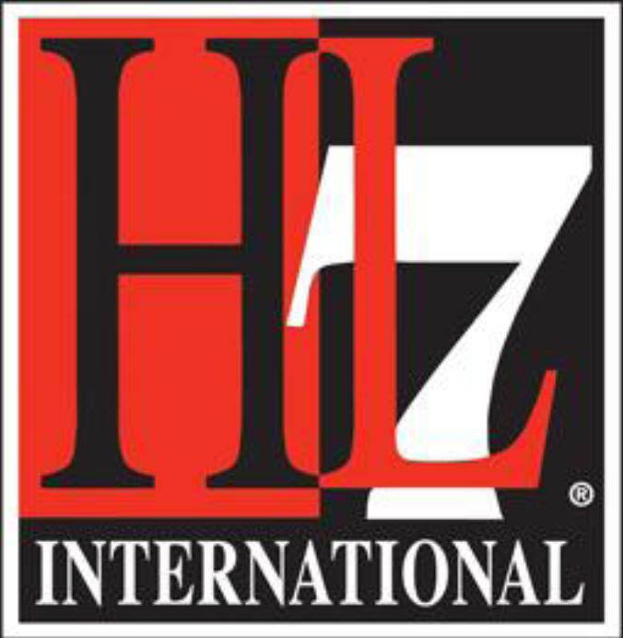 |  | HL7 Working Group Meeting  Atlanta, GA  International Council Meeting  Thursday, January 14, 2016

Draft Agenda
Lunch | 0:30 | 12:30 | - | 1:00
Opening Session |  | 1:00 | - | 3:00 | Melva Peters
- Opening Announcements & Call to Order  - Review Agenda | 0:05 | 1:00 | - | 1:05 | Melva Peters
- Secretary Report  - Confirm Proxies & Quorum  Proxy Held By: For: Affiliate:  Melva Peters Miroslav Koncar HL7 Croatia  Rik Smithies Philip Scott HL7 UK  Alexander Menses Stefan Sabutsch HL7 Austria  Beat Heggli Marco Demarmels HL7 Switzerland  Sylvia Thun Bert Kabbes HL7 Netherlands  Peter Jordan David Hay HL7 New Zeland  Giorgio Cangioli Alexander Berler HL7 Hellas  - Statement of Quorum  - Current Membership = 37 Members  - Quorum for Decisions (40%=16), Directions (33%=13), Financial Decisions (51%=20) | 0:05 | 1:05 | - | 1:10 | Melva Peters
- Secretary Report  - Approval of Minutes from Paris WGM  - HL7 International Council - Sunday - Atlanta - October 2016  - HL7 International Council - Thursday - Atlanta - October 2016  - Review Action Item List | 0:05 | 1:10 | - | 1:15 | Melva Peters
- May 2017 WGM Discussion and request for endorsement  - 01 Madrid Marriott Auditorium Hotel 16-010704.xlsx.pdf  - Madrid Spain 2017 WGM financial forecast as of Jan 7 2016.xls | 0:15 | 1:15 | - | 1:30 | Mark McDougall
- Board Brain Storming | 0:60 | 1:30 | - | 2:30 | Pat Van Dyke
- Internationalization Task Force | 0:15 | 2:30 | - | 2:45 | Pat Van Dyke
- Financial Report  - Review of 2015 Financials  - Budget 2016 Proposals | 0:10 | 2:45 | - | 2:55 | Melva Peters
Break: | 0:30 | 3:00 | - | 3:30
- International representation to the Governance Operations Committee | 0:05 | 3:30 | - | 3:35 | Melva Peters/Ed Hammond
- Presentations  - HL7 Switzerland | 0:30 | 3:35 | - | 4:05 | Beat Heggli
- Presentations for May 2016 WGM – Sunday and Thursday  - Presentation from Argentina  - Presentation from ONC  - PAC Update – Hans B - Thursday  - Internationalization Task Force Update – Pat van Dyke – both Sunday and Thursday | 0:05 | 4:05 | - | 4:10 | Melva Peters
- Decision Making Document | 0:10 | 4:10 | - | 4:20 | Melva Peters
- Nominations Committee – International Rep | 0:10 | 4:20 | - | 4:30
- Closing Remarks | 0:05 | 4:30 | - | 4:35 | Melva Peters

Action Item List
No. | Date Added | Description | Assigned to | Target Date | Status | Notes
Open
10 | 2015-05-14 | Notify CEO/CTO and TSC chair to provide updates that are specific to IC and not what is reported to general sessions | Melva |  | Not Started
14 | 2015-05-14 | Send what it takes to host the meetings (responsibilities, funding, etc.) - IHIC | Frank Oemig |  | Not Started
17 | 2015-10-08 | Create a draft DMP for distribution in advance of the January WGM. Will be reviewed and voted on in January | Line Saele/Melva Peters |  | Not Started
19 | 2015-10-08 | Send email to solicit volunteer for GOC and add to agenda for January | Melva Peters |  | In Progress
Closed
1 | 2015-01-22 | Paris WGM Agenda – Thursday  Policy Advisory Committee Update (Hans)  Support for struggling Affiliates | Melva | April 30, 2015 | Complete
2 | 2015-01-22 | Affiliate Agreement  Confirm with Affiliates how much change is needed to determine how to facilitate review cycle | Melva | April 30, 2015 | Complete | 20150202 – Email sent to Affiliate Chairs
3 | 2015-01-22 | Request for sponsorship from HL7 Sweden  Send out for eVote | Melva | February 15, 2015 | Complete | 20150202 – Email sent to Affiliate Chairs
4 | 2015-01-22 | Email HL7 Sweden to determine if electronic publication was considered | Melva | February 15, 2015 | Complete | 20150202 – Email sent to Affiliate Chair
5 | 2015-01-22 | Email to Affiliates to ask them to consider sharing content to SHARE website | Melva | February 15, 2015 | Complete
6 | 2015-01-22 | Update International Council Wiki | Melva | April 30, 2015 | Complete | 20150202 – Updates made
7 | 2015-01-22 | Email Affiliate Chairs – use of International Council website and Wiki instead of Dropbox | Melva | February 5, 2015 | Complete | 20150202 – Email sent to Affiliate Chairs
8 | 2015-01-22 | October WGM Agenda – Thursday  Presentation from HL7 NL  Presentation from HL7 Australia  Presentation from Argentina  Presentation from Germany or neighbouring Affiliate  PAC Update  Internationalization Task Force Update | Melva | September 1, 2015 | Complete
11 | 2015-05-14 | IC will agree to a short list of country and venues by June 15, 2015 – send an email to the Affiliate Chairs | Melva |  | Complete | 2015-05-16: Email sent to Affiliate Chairs
12 | 2015-05-14 | Italy and Switzerland to respond within 1 month, to report if they can host IHIC 2016 | HL7 Italy  HL7 Switzerland |  | Complete | 2015-05-16: Email sent to Affiliate Chairs
13 | 2015-05-14 | Reach out to all the affiliates to ask for additional host volunteers | Melva Peters |  | Complete
18 | 2015-10-08 | Send out one-page plan and member benefit documents. | Trish Williams |  | Complete | 2015-10-08: Distributed
9 | 2015-05-14 | Affiliate Agreement - Inform Mark and work with HQ to update and review | Melva/Philip | May 30, 2015 | Complete | 2015-05-16 – Email sent to Mark McDougall
15 | 2015-10-08 | Follow-up to determine who will attend and seek support through Board | Ed Hammond |  | Complete
16 | 2015-10-08 | Reach out to FHIR team to determine who may be available | Melva Peters |  | Complete

Affiliates Council Members:
Affiliate / Role | Name | Attendance Record
Co-Chair, Secretary | Melva Peters
Co-Chair | Diego Kaminker
Co-Chair | Francisco Perez
HL7 Board of Directors  IC Representatives | Diego Kaminker
 | Frank Oemig

Members of the Council
HL7 Argentina | Fernando Campos
HL7 Australia | Patricia Williams
HL7 Austria | Stefan Sabutsch
HL7 Bosnia & Herzegovina | Samir Dedovic
HL7 Brazil | Marivan Abrahão
HL7 Canada | Melva Peters
HL7 China | Li Baoluo
HL7 Croatia | Miroslav Koncar
HL7 Czech Republic | Libor Seidl
HL7 Denmark | Gitte Meltofte
HL7 Finland | Juha Mykkanen
HL7 France | Nicolas Canu
HL7 Germany | Christof Gessner
HL7 Hellas | Alexander Berler
HL7 Hong Kong | Chung Ping Ho
HL7 India | Chandil Gunas
HL7 Italy | Stefano Lotti
HL7 Japan | Michio Kimura
Hl7 Korea | Byoung-Kee Yi
HL7 Malaysia | Mohamad Azrun Zubir
HL7 Netherlands | Robert Stegwee
HL7 New Zealand | David Hay
HL7 Norway | Line Saele
HL7 Pakistan | Maajid Maqbool
HL7 Philippines | Michael Hussin Muin
HL7 Puerto Rico | Julio Cajigas
HL7 Romania | Florica Moldevenue
HL7 Russia | Sergey Shvyrev
HL7 Singapore | Adam Chee
HL7 Slovenia | Brane Leskosek
HL7 Spain | Francisco Perez
HL7 Sweden | Mikael Wintell
HL7 Switzerland | Marco Demarmels
HL7 Taiwan | Chih-Chan (Chad) Yen
HL7 Turkey | Ergin Soysal
HL7 UK | Philip Scott
HL7 Uruguay | Julio Leivas
HL7 USA | Ed Hammond

Lapsed Affiliates
HL7 Luxembourg
HL7 Mexico

