**Inconsistent template version numbers between Volume 1 and Volume 2:**

* **Procedure Order, Procedure Recommend** and **Procedure Performed** in Volume 1 Appendix A *Table 15: HQMF QDM Pattern to CDA Template Mapping Table* have template version V4, but in Volume 2, all of them have shown as V5.

* **[Substance Recommended](" \l "E_Substance_Recommended)** in Volume 1 Appendix A *Table 15: HQMF QDM Pattern to CDA Template Mapping Table* have template version V5, but in Volume 2, it is V4. Similarly, the extensions are inconsistent.
* Another inconsistency on **Procedure Activity Observation (V2)** template extension as shown in below screen shot. This is from Volume 1 Appendix A Table 16: *HQMF QDM Attribute Patterns to CDA Elements in Specific Templates Mapping Table*



**Several issues noticed in Volume 2:**

* **Laboratory Test Performed** Example in Figure 58 still has the old wordings (“Conforms to C-CDA R2.1 Result Observation”), and old template version (V3)/extension (2016-02-01).

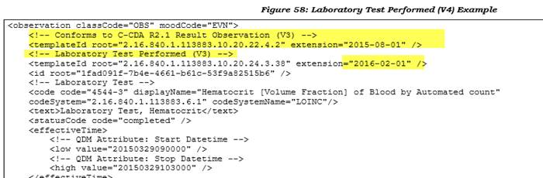

* **Author** Example in Figure 138 is using a wrong template ID.   The correct one should be @root="2.16.840.1.113883.10.20.24.3.155"

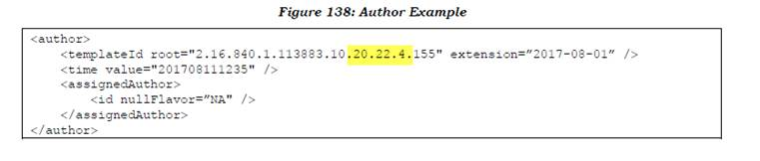

* **Assessement Performed** template in Table 269: Template Containments has wrong version (V3) and extension

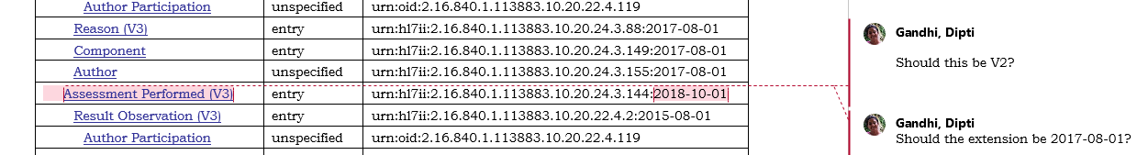

* **T**emplate version is missing in Figure 40 as shown bel
* A couple of comments for Figure 58

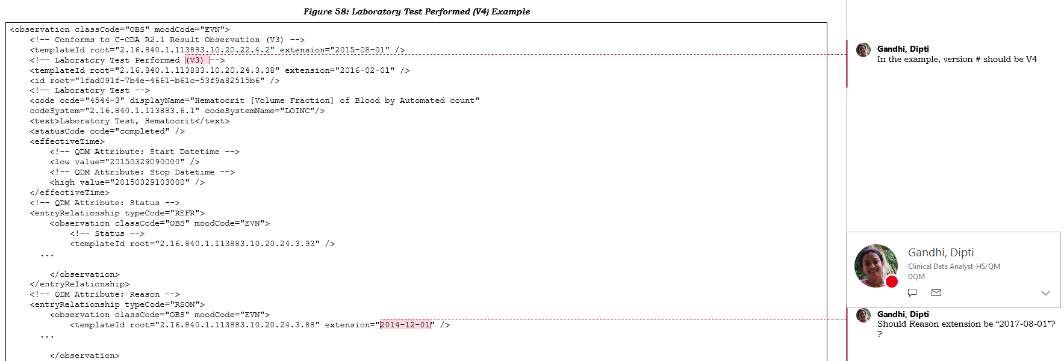

* Comment for Figure 63

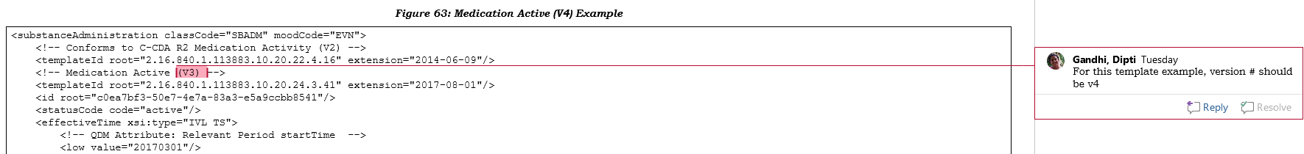

* Comment for Figure 64

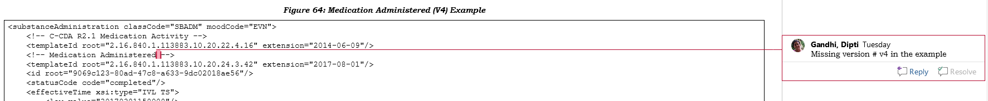

* Comment for Figure 72



* Comment for Figure 115

